2D & 3D Digital Submission Standards for Development Applications

City of Cambridge - 2026

Table of Contents
1. What are Digital Submission Standards? 3
2. What are 2D Submissions vs. 3D Submissions? 3
3. How are Digital Submissions Used? 4
4. Submission Type by Development Application 5
5. Submission Standards 6
5.1 2D Submissions 6
a) Required Files 6
b) File Structure & Formatting 7
c) Naming Conventions 7
5.2 3D Submissions 8
a) File Name 8
b) Format 8
c) Model elements 9
d) Layer Structure 10
d) Level of Detail (LOD) 11
e) Geolocation 12
f) File Size 13
6. Technical queries 13

What are Digital Submission Standards?
Digital submission standards are the rules, requirements, and specifications that govern how digital files, documents, drawings, or data must be prepared and submitted to the City of Cambridge with certain types of development applications.

These submission standards are enforced by the City to ensure submissions are clear, comprehensive, and uniform in order to achieve the following goals:
- Enhanced customer service
- Better integration between AutoCAD submissions and City of Cambridge’s GIS databases
- Improved data accuracy by ensuring that all necessary asset information of the drawings can be visually extracted
- Easy to organize, manage, and find attached plans in AMANDA and other corporate software
- To maintain an updated citywide 3D digital twin
- Assist with the review of development applications.

It is the developer’s responsibility to ensure that all digital submissions are complete, accurate, and formatted according to the City’s standards found in Section 5. This includes submitting all required PDFs and AutoCAD files in the appropriate formats and meeting the submission deadlines.
The City’s GIS team will review the submissions to ensure compliance with the City's GIS standards and specifications. The City will provide feedback if revisions or additional information are required.

What are 2D Submissions vs. 3D Submissions?
A 2D submission presents the project using traditional engineering and architectural drawings viewed in plan, profile, and section formats. 2D Plans are characterized as:
- Flat drawings with X and Y coordinates
- Elevations shown separately through contours, spot grades, and profiles
- Usually delivered as PDFs and CAD files (DWG/DGN).
Plans and drawings typically presented in 2D format include:
- Site plans
- Grading plans
- Servicing plans
- Profiles and cross-sections
- Landscape plans
- Architectural floor plans and elevations
- Survey drawings.
A 3D submission provides a digital model containing spatial information about the project. Instead of separate drawings, the reviewer can visualize and analyze the project in three dimensions. 3D Plans are characterized as:
- Uses X, Y, and Z coordinates
- Represents real-world geometry and elevations simultaneously.
Plans and drawings typically presented in 3D format include:
- Building information models (BIM)
- 3D site models
- Digital terrain models (DTM)
- Infrastructure asset models.

How are Digital Submissions Used?
The City may request a 2D submission of the CAD files (DWG/DGN) matching an associated PDF in accordance with the Submission Type by Development Application Chart in Section 4 to accelerate the digitization of GIS datasets. This will aid in the accurate creation of parcels, addresses, roads, and other assets that can be referenced to inform important planning decisions.
Likewise, 3D models of a proposed development may be requested in accordance with the Submission Type by Development Application Chart in Section 4 to accelerate the design process by carrying out more streamlined and accurate appraisals. The proposed development’s 3D digital model will be inserted into the Cambridge Digital Twin and used internally to help expedite crucial planning assessments such as:
- Built form and massing compliance and impacts
- Overshadowing and viewshed impacts on public realm
- Heritage fabric response
- Context character response
- Other planning and urban design related assessments.
3D models of live and approved applications may also be displayed in our public online Digital Twin viewing platform for development activity monitoring and visualization purposes. By submitting your model, you agree to its use in the Public 3D Digital Viewer once it has been approved by the Planning Department to be shared publicly. Building internals will not be shown to the public, only the outer form.
An as built version of the model after construction is finished would also be greatly appreciated to ensure that the Digital Twin accurately reflects the completed development.

Submission Type by Development Application
The following table summarizes when a developer is expected to submit a 2D and/or 3D Submission by Application Type:
Development Application Type | 2D Submission | 3D Submission
Pre-consultation for Any Application | Not Required | Not Required
Formal OPA or ZBA | Not Required | Recommended
Subdivision and Condominium | Submit PDF and AutoCAD files at the following stages:  - Submission of the Application to deem the application complete:  The applicant is required to submit the digital file of the plan at the time of original application. As well, revisions to the plan arising out of the review process must be provided. This is necessary to deem the application complete.  - To Grant Draft Approval: The AutoCAD file (.DGN or .DWG) must be modified to reflect any changes arising out of the circulation and review stage. The final draft plan submission must be submitted prior to planning staff preparing the staff report to draft approval.  - Subdivision Registration: The applicant is required to submit the final .DGN or .DWG and .PDF files representing the plan to be registered. This is necessary to grant final approval. | Not Required
Part Lot Control Exemption | Submit at the following stages:  - A PDF with a complete part lot control exemption application.  - A PDF and AutoCAD files prior to the issuance of final approval. | Not Required
Site Plan Control | Recommended | Submit upon receiving final site plan approval

Submission Standards
Each new 2D and 3D submission must match the following standards.

5.1 2D Submissions

a) Required Files
For each new drawing/plan or any modification to a drawing/plan, the developer must submit:
- A digital CAD file of the plan in .DGN or .DWG format. These should be in AutoCAD 2013 or later.
- A digital .PDF file of the plan, preferably in 24” x 36”. This must be an exact copy of the .DGN or .DWG AutoCAD plan as described.

b) File Structure & Formatting
The submitted files must adhere to the following requirements:
- The CAD file must be georeferenced to the City of Cambridge’s GIS corporate database projection of NAD 1983 UTM Zone 17N.
  - Upon request, the City of Cambridge can provide parcel mapping at no cost for the subject area and surrounding properties to assist with georeferencing. This can be sent to the applicant in AutoCAD format (.DWG) after a data license agreement has been signed.
- The CAD file must have map units and features set to the metric system, preferably meters where applicable, and be unscaled (1:1).
- Colors, weights, and symbols are at the developer's discretion, so long as they are consistent and easily intuitive.
- All features/layers, georeferencing, format, and names must remain accurate and consistent throughout all stages of submission.
- When necessary, all line segments must snap together and close to create polygons.

c) Naming Conventions
All 2D files must be named according to the following conventions:
Submission Date YYYYMMDD_ Street Number_Street Name_Status
e.g., 20260131_50_DicksonSt_SPA
Status Acronyms:
- Plan of Subdivision
  - SUB-PROP – Subdivision - Proposed
  - SUB-DA – Subdivision - Draft Approved
  - SUB-REG – Subdivision - Registered
- Plan of Condominium
  - COND-PROP – Condominium - Proposed
  - COND-DA – Condominium - Draft Approved
  - CON-REG – Condominium - Registered
- PLCE – Part Lot Control Exemption
- SPA – Site Plan Approval
- AB – As Built
Naming conventions for all features/layers within a file must adhere to the following standards:
- All features/layers must have the “GIS_” prefix (i.e., GIS_BUILDING).
- All feature/layer names must include the feature status, using the “EX_” prefix for existing features, “REM_” for removal layers, or the “PR_” prefix for proposed features, unless otherwise stated. This prefixes the feature name and must go after the “GIS_” prefix (i.e., GIS_EX_BUILDING, GIS_REM_BUILDING, and GIS_PR_BUILDING).
- For all text types, the feature name must include the “TX_” to be placed between the “GIS_” prefix and the status prefix, unless otherwise stated (i.e., GIS_TX_PR_BUILDING).
- All names shall be capitalized, ensuring consistency and readability.

5.2 3D Submissions

a) File Name
Please name the model using the following convention:
Submission Date YYYYMMDD_ Street Number_Street Name_Status
e.g., 20260131_50_DicksonSt_SPA
Status Acronyms:
- PRE-OPA – Pre-consultation Official Plan Amendment
- PRE-ZBA – Pre-consultation Zoning Bylaw Amendment
- PRE-SP – Pre-consultation Site Plan
- OPA – Formal Official Plan Amendment
- ZBA – Formal Zoning Bylaw Amendment
- SPA – Site Plan Approval
- AB – As Built

b) Format
Preferred:
- ESRI 3D Multipatch File Geodatabase (FGDB)
- Industry Foundation Classes (IFC)
- Revit (RVT)
Acceptable:
- COLLADA (DAE)
- Wavefront (OBJ)
- Autodesk Filmbox (FBX) & Autodesk Drawing (DWG)
- VRML or GeoVRML (WRL)
- Openflight (FLT)
- 3D Studio Max (3DS)
- Universal Scene Description (USDC, USDZ)
- GL Transmission Format (glTF)
- Binary GL Transmission Format (glb)
If you cannot submit any of the above file formats, please get in touch with your assigned planner to see if your 3D file type can still be accepted into our system.

c) Model elements
Measurement Unit: Metres, at a scale of 1:1
Requested:
- Building Envelope/External Building Structure
  - Including significant projecting devices and defining architectural elements such as canopies, overhangs, parapets, lift overruns, and building crown features.
  - Models should display the accurate building height, major massing components, proposed roof shape, and all staggered/stepped elevations.
  - The purpose of the model is to give a reasonable impression of the form of the proposed building.
  - Ideally, building models developed on flat planes should extend beneath the ground surface to account for any changes in ground elevation levels.
- Regraded Elevation Surface
  - If any significant changes are made to existing site ground levels, please include the regraded site elevation as a 3D surface layer OR half-metre contour lines as soon as it is available.
  - If an elevation surface cannot be provided:
    - At minimum, measurements for the base grade elevation are required. The elevation measurements should be in metres above sea level with reference to the City’s vertical datum: CGVD2013a (EPSG:9245). If a different datum is used, please specify the name of the datum and coordinate system.
- Landscape Objects
  - Proposed street furniture, fences, trees, vegetation, and other landscaping elements as 3D objects.
Optional:
- Landscape Surfaces
  - Surface level parking, greenspaces, and other landscape elements as a 3D surface.
- Pedestrian/Vehicular Networks
  - Pedestrian and vehicular networks on property and in surrounding context such as sidewalks, roads, and other paths as a 3D surface.
Not Requested:
- All internal furniture, fixtures, and fixings.
- Mechanical, electrical, and plumbing (MEP) elements and other underground infrastructure.
- People, cars, and other entourage elements.

d) Layer Structure
Please organize your model into the following layers/tags and utilize the layer names indicated in the parentheses:
Required
- Building Envelope (BUILD_ENV)
- Regraded Elevation Surface (REGRADE_SURFACE) or Measurements for the Base Grade Elevation
- Landscape Objects (LAND_OBJECT)
Optional
- Landscape Surfaces (LAND_SURFACE)
- Pedestrian/Vehicular Networks (TRANS_NETWORK)
- Other (OTHER)

d) Level of Detail (LOD)
Applicants are recommended to provide 3D models in LOD 1.2 for the pre-consultation, zoning bylaw amendment, and official plan amendment stages of an application.
At the site plan approval stage, the model is expected to be at LOD 3.2. The minimum accepted at this stage would be LOD 2.3, including detailed and accurate roof form and roof overhangs. Examples of what this would look like are visible in the illustration below:
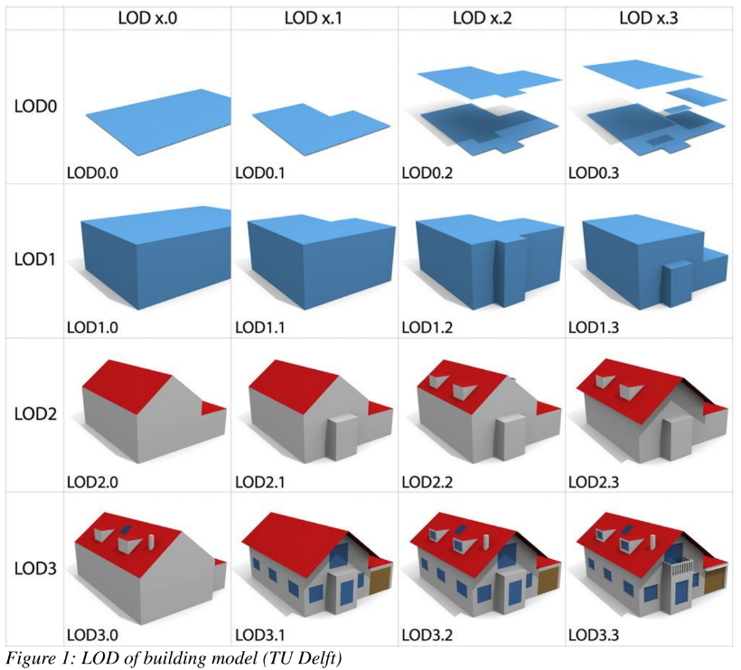

An example of the ideal model submission at site plan approval, at least LOD 3.2 with surface textures:
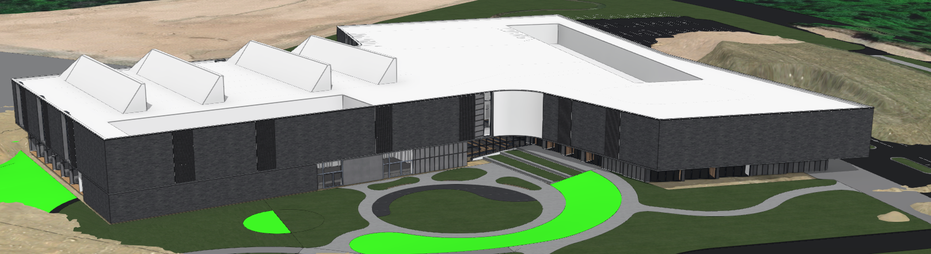

e) Geolocation
• Coordinate System: The coordinate system accepted is NAD 1983 CSRS UTM Zone 17N (EPSG: 2958)
• Vertical Datum: The vertical datum accepted is CGVD2013a (EPSG:9245)
Geolocate the 3D model to its accurate location in the City’s geographic coordinate system, NAD 1983 CSRS UTM Zone 17N (EPSG: 2958), and its accurate elevation in the City’s vertical datum, CGVD2013a (EPSG:9245). If a different vertical datum is used, please specify the name of the datum and coordinate system.
If you are unable to geolocate your model, it should be zeroed to World Origin (0,0). If your model is zeroed, you will need to provide NAD 1983 CSRS UTM Zone 17N (EPSG: 2958) compliant coordinates for a point on your model, including elevation in metres above sea level with reference to the City’s vertical datum: CGVD2013a (EPSG:9245). If a different vertical datum is used, please specify the name of the datum and coordinate system.

Reference Data:
To support collaboration with the construction and development community, the City will provide a 3D context LOD 2.2 model of Cambridge on request.
A pre-georeferenced seed file clipped to the parcel boundary of your proposed development site to build your submission within is also available upon request at no extra cost.

f) File Size
File sizes for submitted 3D models, including textures, should be kept as low as possible. Less than 32MB in size is preferred. At most, any single file should be under 100MB.
Large textures contribute to large model file sizes. Consider optimizing or removing your textures if your submission is over the limit.

Technical queries
For technical assistance please contact the GIS team, Technology Services at gis@cambridge.ca

