THE CORPORATION OF THE CITY OF CAMBRIDGE
BY-LAW 26-063
Being a by-law to adopt a water allocation policy pursuant to section 86.1 of the Municipal Act and to delegate certain powers and duties to staff pursuant to the Municipal Act, 2001 regarding the implementation of such policy
WHEREAS Section 11 of the Municipal Act, 2001, S.O.2001, c.25, as amended (the “Act”) authorizes The City of Cambridge (the “City”) to pass by-laws respecting public utilities;
AND WHEREAS sub-section 86.1(1) of the Act permits municipality to adopt a policy providing for the allocation of water supply capacity;
AND WHEREAS there are policies in the City’s Official Plan which provide direction in the monitoring of servicing capacity and regard for competing demands for servicing capacity;
AND WHEREAS the Region of Waterloo is responsible for the water supply that services the City;
AND WHEREAS the Region’s water supply has limited capacity available for allocation to new development;
AND WHEREAS the Region of Waterloo has adopted a policy entitled Water Supply Capacity Allocation Policy for the Mannheim Service Area, which proposes to incrementally allocate certain fixed additional water supply capacity to lower tier municipalities within the Mannheim service area;
AND WHEREAS paragraph 6 of sub-section 270(1) of the Act, requires a municipality to adopt and maintain policies with respect to delegation of its powers and duties; and,
AND WHEREAS the Council of The Corporation of the City of Cambridge deems it expedient to delegate authority to the General Manager of the Planning and Growth Department to make allocation decisions pursuant to the enclosed Policy, and,
AND WHEREAS the allocation of available water supply capacity is at the discretion of the City; and,
AND WHEREAS the Council of the City wishes to manage the available capacity of the water supply in a sustainable and logical manner;
NOW THEREFORE BE IT RESOLVED THAT, the Council of The Corporation of the City of Cambridge enacts as follows:
1. In order to:
- properly manage the City’s water capacity in the Mannheim Service Area, as assigned by the Region of Waterloo;
- protect the health and safety of the public;
- ensure that servicing capacity can be provided to those projects that provide the greatest benefit to the City;
- ensure that servicing capacity can be provided to those projects most likely to proceed in the immediate future; and,
- maintain the public interest and realize municipal objectives,

The City hereby adopts the “Water Allocation Policy” as set out in Schedule “A” and “Water Allocation Prioritization Framework” as set out in Schedule “B” which are attached hereto and which form part of this By-law.
2. In accordance with Section 86.1(3) of the Act, the administration of the policy is hereby delegated to the General Manager of the Planning and Growth Department, with all decisions made by the General Manager and/or City Manager to be final.
3. The General Manager of the Planning and Growth Department is hereby delegated exclusive authority to issue a Water Allocation Confirmation Letter, revoke assigned water capacity and enter into and execute Agreements pursuant to the Water Allocation Policy, to the satisfaction of the City Solicitor.
4. This By-law shall take effect on the date of passing.
5. This By-law shall come into force and take effect upon the enactment thereof.

PASSED at the Council Chambers in the City of Cambridge this 21st day of July, 2026.

________________________
Mayor

________________________
Clerk

POLICY TITLE Water Allocation Policy and By-law
CATEGORY Municipal Services
POLICY NUMBER ADM 065
DEPARTMENT Planning and Growth
POLICY AUTHOR Planning Services
POLICY TYPE Administrative Policy
APPROVED BY Council
EFFECTIVE DATE 07/21/2026
REVIEW DATE 07/21/2027

POLICY STATEMENT
The City of Cambridge (“the City”) is currently facing servicing challenges due to the Region of Waterloo’s (“the Region”) water supply capacity constraint. Water supply to be allocated for growth is currently limited due to the ongoing constraint within the Manheim Service Area, as identified in Schedule A. Water Supply Capacity from the Region is based on their Interim Risk Management Framework Report Study (IRMF) which is an iterative document that will be updated and refined as additional information becomes available.
In response to these challenges, the City must develop a water allocation policy related to the assignment of servicing capacity in that area which balances the risks for the development community and the Region as water service provider and the City as the water distributer.
In alignment with these objectives, this Water Allocation Policy, (the “Policy”) has been prepared to address the escalating pressures on water infrastructure and to ensure the prioritization of projects while considering:
- community benefit, affordable housing and sustainability;
- complete communities and planning in the public interest; and,
- supporting the growth of the community’s population and economy.
This Policy serves as a strategic guide for the City to facilitate accountable and prudent decision-making in the face of increasing and competing development pressures and available capacity. The Policy framework serves as a transparent tool to assess and evaluate developments consistently.
By implementing this Policy, the City aims to strike a delicate balance between accommodating competing developments within existing infrastructure constraints or planned project capacities and safeguarding the long-term provision of water, while advancing and considering community objectives. This proactive approach is not only complementary to the existing development processes but also promotes transparency and fairness in the decision-making process for developments.
By incorporating these considerations into the evaluation process, the City endeavors to make informed decisions that prioritize responsible and sustainable growth.
On June 6, 2024, Bill 185, Cutting Red Tape to Build More Homes Act, 2024, received Royal Assent. This Act introduced to the Municipal Act, 2001 including the addition of a new section 86.1. This new section enables municipalities to pass by-laws to adopt policies to establish systems for tracking the water supply available to support approved developments, through the establishment of allocation criteria. This Policy conforms to the Municipal Act, as amended.

PURPOSE
This Policy is intended to guide the City’s prioritization process for issuing assigned water capacity in accordance with this Policy, on consideration of the Region’s policy: Water Supply Capacity Allocation Policy for the Mannheim Service Area.
To provide a clear and cohesive set of guidelines that will govern the equitable evaluation of assigned water capacity criteria to meet the evolving needs of the City in the most beneficial manner possible.
To establish a prioritization framework for assigned water capacity in accordance with the City’s building permit application and development application approval process, to support residential and industrial, commercial, and institutional (ICI) development that promotes sustainable growth and prosperity for the City.
This Policy includes a system for tracking assigned water capacity to support developments, and report back to the Region, as well as criteria to determine the circumstances for when:
a) assigned water capacity is issued for a development, including any Forward Looking Servicing Agreement(s),
b) the terms and timing of how assigned water capacity may be revoked, and;
c) the process for reissuing assigned water capacity.

DEFINITIONS

“Affordable Housing” and/or “Affordability” and/or “Affordable” means Affordable Residential Unit as defined in the Development Charges Act, 1997, and/or Affordable Housing as defined by the Canadian Mortgage and Housing Corporation.
“Allocated/Allocation” means the action of apportioning a specified volume of water supply capacity in the City in accordance with this Policy. “Allocate” shall have a corresponding meaning.
“Assigned Water Capacity” means the volume of water supply capacity that is issued, committed, or confirmed to an approved development for a specified period of time by the City in accordance with this Policy. For clarity, the assigned water capacity is presented in units of litres per second and is subject to a water capacity confirmation letter.
“Building Code Act” means the Ontario Building Code Act, 1992, S.O. 1992, c. 23, as amended and all regulations thereto.
“City” means the City of Cambridge and where the context so implies includes its council, employees, solicitors, officers and agents.
“City Manager” means the individual appointed by the City to serve as the City Manager of the City of Cambridge and includes any successor to that position.
“Council” means the municipal Council of the City of Cambridge.
“Development” means one or more of the following:
- the creation of a new lot or block
- a change or intensification in use
- the erection or construction of a building, structure, and/or addition requiring approval under the Planning Act or Building Code Act.
- the relocation of a building or structure
- all scenarios outlined in this Policy except where excluded in this Policy.
- a single phase of a site plan
- a single phase of a plan of subdivision
- a draft approved vacant land condominium
- requiring approval under the Planning Act or Building Code Act
- redevelopment
“Forward Looking Servicing Agreement” and/or “FLSA” means an agreement executed in accordance with this Policy.
“General Manager of Planning and Growth” or “GM PG” means the individual appointed by the City to serve as the General Manager of the Planning and Growth Department, and includes any successor to that position.
“High Water Users” means a development which uses water at a rate of 0.231 L/sec and/or 7.3M L/year based on information provided through an approved development application and/or as verified through water meter reading.
“Prioritization Framework” means the prioritization framework attached hereto as Schedule B.
“Material” and “Materially” shall be determined by the GM PG, guided by the position that increases in water demand are determined on the basis that an extension, upgrade, and/or provision of new main line/water supply is required.
“Municipal Act” means the Municipal Act, 2001, S.O. 2001, c. 25, as amended and all regulations thereto.
“Planning Act” means the Ontario Planning Act, R.S.O. 1990, c.P.13, as amended and all regulations thereto.
“Proponent” means any person, corporation, customer or organization that applies to the City for water supply capacity in connection with a proposed development in accordance with this Policy. The Proponent must be the registered owner of the land that is the subject of the proposed development but may elect to be represented by another person or agent.
“Qualified Professional Engineer” means an individual in good standing duly licensed by Professional Engineer Ontario (PEO) to practice professional engineering in the Province of Ontario and
- qualified to undertake functional engineering in regard to the proposed development including calculating water servicing demand; and
- permitted by law to undertake and assume responsibility for engineering work in the Province of Ontario.
“Region” means the Regional Municipality of Waterloo and where the context so implies includes its council, employees, solicitors, officers and agents. “Regional” shall have a corresponding meaning.
“Reserve Capacity” means the volume of water that is determined by subtracting all assigned water capacity from the water supply capacity presented in units of litres per second.
“Water Allocation Confirmation Letter” means the official confirmation from the City whether or not assigned water capacity, if any, has been allocated to a development, issued in accordance with this Policy.
“Water Allocation Policy” and/or “Policy” means this Policy, as adopted by City Council to provide guidance, direction, and procedures to issue assigned water capacity and which includes the City’s prioritization framework, including all appendices thereto, which may be amended from time to time.
“Water Capacity Application Form” means the application form filed by a Proponent to request water supply capacity be assigned to their development. This form will be required to be submitted for any development as outlined in this Policy.
“Water Supply Capacity” means the amount of available unallocated water that has been allocated to the City by the Region and available for further allocation to Proponents by the City at its discretion.
Any other term that is not defined in this Policy shall be interpreted to have the same meaning prescribed to it in the City’s Official Plan and/or Zoning By-law.

AUTHORITY
Council has decision-making authority over the allocation of assigned water capacity in the City.
Council has delegated the authority to the General Manager of Planning and Growth Department (GM PG) to administer this Policy, issue assigned water capacity, issue water allocation confirmation letters (including any extensions), with or without conditions, revoke or amend assigned water capacity, and execute forward looking servicing agreements (FLSA) pursuant to this Policy.
Pursuant to subsection 86.1(3) of the Municipal Act, a decision of the GM PG made under this Policy shall be final.
In the event a Proponent disagrees with the water allocation confirmation letter, the Proponent may submit a written detailed objection within 10 calendar days to the City Manager for consideration. The City Manager shall dialogue with the GM PG, and any other person or party the City Manager determines appropriate at their discretion. Any decision of the GM PG after consulting with the City Manager shall be final in accordance with subsection 86.1 (3) of the Municipal Act. The GM PG shall advise the Proponent in writing of their decision to any objection submitted.

DETERMINING THE ALLOCATION CAPACITY
The Region is responsible for determining water supply capacity and identifying and providing new water capacity available for allocation by the City. Water capacity is to be based on design flows as calculated per the respective service areas characteristics.
The City is responsible for the allocation of available water supply capacity as provided to by the Region, at the City’s sole and unfettered discretion.
Prior to the allocation of water supply capacity, the City may require a Proponent to provide a stamped report from a Qualified Professional Engineer that calculates the average and maximum servicing demands (including water) for a site-specific residential, mixed-use, industrial, commercial, and/or institutional proposal/development, to the satisfaction of the GM PG. The City reserves the right to peer review the report at its discretion. All costs shall be borne by the Proponent, including peer review costs.

POLICY

SCOPE
- This Policy applies to the following development within the Manheim Service Area of the City:
- Any Development where an extension, upgrade, and/or provision of new main line/water supply is required, except as specified below;
- The City may require a water capacity application form for a development, and upon review, may determine this Policy does not apply to the following:
- The development of existing vacant lots where no approval under the Planning Act is required;
- Any school, day care facility, and place of worship;
- Any development or lot or block in a registered plan of subdivision that has a signed servicing agreement with the Region and included in the Regional reserve capacity (registered unbuilt Regional inventory);
- a development on a parcel of land created by a consent/severance application pursuant to section 53 of the Planning Act where:
  - a ‘Certificate of Official’ has been issued on or before December 22, 2025;
  - the development can be serviced by a municipal water service of 25.4mm (1 inch) or less;
  - no Planning Act approvals are required;
  - no consent/severance agreement exists that requires the verification of sufficient water supply capacity prior to development, which verification remains outstanding;
- like-for-like development, meaning the replacement of an existing building or structure within two (2) years where:
  - the proposed development does not materially increase the water supply demand for the existing building;
  - the approved municipal water service is not increased, except for a historic residential lot where the existing municipal water service may be increased to 25.4mm (1 inch) to comply with the Building Code Act;
  - the use of land is permitted under applicable zoning;
  - no agreement exists that requires the verification of sufficient water supply capacity prior to development, which verification remains outstanding.
Includes the incorporation of one or more Additional Dwelling Units into the proposed development as defined in the City’s Zoning By-laws, provided the above criteria are satisfied;
- a development for which a building permit was issued under the Building Code Act on or before December 22, 2025;
- any other development or works where the City is satisfied that no new material demand is created on the water supply system (e.g., installation or expansion of fire protection systems);
- a model home building permit; and
- where water capacity is provided by the Region in accordance with the Region’s Water Supply Capacity Allocation Policy and/or the Allocation Policy Administrative Agreement, and/or where a valid servicing agreement or Regional FLSA has been executed between the Region, the City, and/or a Proponent.
Procedures & Criteria
- A Proponent is required to complete a water capacity application form and submit it electronically to planning@cambridge.ca. The City will direct the form to the appropriate Division, depending on the nature and status of the applicable building permit or development applications.
- Issuance of assigned water capacity shall be determined based on the City of Cambridge prioritization framework, and where applicable, the secondary criteria noted below, all at the discretion of the GM PG.
- On a quarterly basis, or more frequently as applicable, where the Region has provided new water capacity available for allocation by the City, the City will review all water capacity application forms and issue a water allocation confirmation letter and/or a FLSA for a development in accordance with this Policy.
- A Proponent will receive and review the water allocation confirmation letter and return a signed copy to the City, thereby agreeing to any terms contained therein.
- The GM PG will sign the returned water allocation confirmation letter, confirming the final decision for a development.
The following apply to the applicable development applications:
- Based on available water capacity, those development applications that are prioritized through the City of Cambridge prioritization framework may receive assigned water capacity. In a quarter where demand exceeds available capacity, not all developments will receive assigned water capacity.
- If two or more developments are considered equal based on the City of Cambridge prioritization framework, the City may request supplemental information from proponents before making a decision. Secondary prioritization criteria shall include:
  - for proposed developments containing affordable housing, the percentage of affordable housing compared to the density of the development, with higher percentages receiving preference,
  - the date of the related development application (with older applications receiving preference),
  - how close the development is to proceeding to construction (shovel readiness) with those projects closest to shovel readiness proceeding given preference,
  - inclusion of measurable water conservation measures, such as high efficiency in-building fixtures exceeding Building Code Act requirements and/or the use of rainwater harvesting systems to reduce reliance on municipal water for applicable non-potable uses (e.g., irrigation, urinals, and trap primers), where such measures are confirmed by a Qualified Professional Engineer and noted on all permit drawings and with supporting technical documentation, and
  - other criteria as determined relevant by the GM PG.
- If a development is not granted an allocation, the City will notify the Proponent and may outline the reasons for the decision to support Proponent’s reconsideration in the next intake period.
- Mixed-use developments will be proportionately categorized as residential and non-residential based on the number and type of dwelling units, and non-residential floor area and use.
- The City shall evaluate each development in conjunction with the relevant and submitted materials and applicable reports provided in the water capacity application form. The City may retain an independent consultant to assist in the review of submissions and supporting studies using the City of Cambridge prioritization framework and any other consideration deemed relevant by GM PG.
Issuance of Assigned Water Capacity
The following processes will apply to the applicable development applications:
- Building Permit Application
  - The Proponent shall obtain assigned water capacity for a development as well as a water allocation confirmation letter prior to the issuance of a building permit where no FLSA has been executed, or
  - The Proponent shall enter into a FLSA with the City prior to the issuance of a conditional building permit.
- Plan of Subdivision and Residential Vacant Land Condominium Applications
Where a valid Agreement for Servicing with the Region does not exist, the Proponent shall;
  - obtain assigned water capacity for the development as well as a water allocation confirmation letter from the City prior to servicing for a development, or
  - enter into a FLSA with the City prior to registration.
- Site Plan Application
Where construction and occupancy is expected to take 12 or more months from the issuance of final site plan approval, the Proponent shall;
- Obtain assigned water capacity for the development as well as a water allocation confirmation letter from the City prior to final site plan approval, or
- enter into a FLSA with the City prior to the issuance of final site plan approval for a development.
Where construction and occupancy is expected to take less than 12 months from the issuance of final site plan approval, assigned water capacity may be determined through the process established in this Policy for building permit applications.
- Consent/Severance/Creation of a New Lot
The City will recommend a condition of provisional approval that requires a Proponent to obtain assigned water capacity for the development as well as a water allocation confirmation letter from the City prior to final approval.
Where assigned water capacity is allocated by the City, the Proponent will be required to sign back the water allocation confirmation letter with the City which will outline:
- The total amount of assigned water capacity issued by the City,
- The details of the development, including the number of residential units, and/or floor area of non-residential uses,
- The date of the assigned water capacity decision may be revoked or expire,
- Restrictions and/or prohibitions on the transfer of the assigned water capacity to any person or entity other than the Proponent and/or any other development.
A water allocation confirmation letter will be sent to the Proponent for signing, where the Proponent shall agree to the terms and conditions contained therein. After the Proponent returns the signed water allocation confirmation letter to the City, the GM PG will sign it on behalf of the City, which will be considered the final decision. Original or verified electronic signatures will be accepted for water allocation confirmation letters to the satisfaction of the City Solicitor.
A water allocation confirmation letter may be amended by the City and the Proponent. However, if additional water capacity is required for the development the City may deem the assigned water capacity to be revoked and the allocation process may be restarted to secure the additional water capacity, at the sole and unfettered discretion of the GM PG.
A water allocation confirmation letter may be extended by the GM PG for up to one (1) additional year, which can be granted at the sole and unfettered discretion of the GM PG based on the following criteria:
- Unforeseen circumstances which have caused delays in carrying out the development;
- New legislation, regulations, policies and/or by-laws have caused delays in carrying out the development, provided that the development continues to be permitted and viable under the new legislation, regulations, policies and/or by-laws.
Where a development has its assigned water capacity withdrawn, revoked or expired, the development shall be subject to the requirements of this Policy as if it had never received an assigned water capacity, including restarting the review process to secure a new allocation of water supply capacity.
Issued assigned water capacity as outlined in a water allocation confirmation letter will exclusively apply to the development outlined in the water capacity application form and is not transferrable and not assignable to any other property, owner, entity or development, except by an amended water allocation confirmation letter executed by the GM PG. The application process to transfer assigned water capacity shall mirror the application process for a new water capacity application form. Any attempt to transfer or reassign the assigned water capacity in a manner contrary to a water allocation confirmation letter will result in the immediate revocation of the assigned water capacity.
Forward Looking Servicing Agreements
At the City’s sole discretion, the City may enter into a FLSA in accordance with this Policy.
An executed FLSA will, at a minimum, specify the volume of anticipated water supply capacity that the City will reserve capacity for a development until future water supply capacity is made available by the Region, and other matters, on terms and conditions approved by the City at its sole discretion.
The FLSA will have regard for the Region’s Water Supply Capacity Allocation Policy and/or the Allocation Policy Administrative Agreement between the Region and Area Municipalities.
A FLSA will represent a commitment in good faith by the City to reserve capacity future anticipated water supply capacity in accordance with the timelines outlined in the FLSA and relies on the Region’s approved Interim Risk Management Framework.
A FLSA will require certain milestones to be achieved by the Region as the water supplier in accordance with the Region’s approved Interim Risk Management Framework which identifies the amount and timing of anticipated new water supply capacity within the region on a quarterly basis until 2032. The City will make all reasonable efforts to ensure that water supply capacity is reserved for the development as outlined in a FLSA.
The City is not the water supplier, and as such it cannot provide a guarantee regarding anticipated water supply capacity or the timing thereof. If a Proponent elects to undertake works and/or development under a FLSA, it is doing so at its sole cost and risk.
Expiry of Assigned Water Capacity (Use It or Lose It Provision)
If assigned water capacity is allocated by the City, at its sole and unfettered discretion, the GM PG may revoke assigned water capacity where:
- Building Permit
If after six (6) months after permit issuance, the construction in respect of which the building permit was issued has not, in the opinion of the Chief Building Official, been seriously commenced.

- Plan of Subdivision and Residential Vacant Land Condominium Applications
- If, after twelve (12) months from the date of draft approval, the development has not proceeded to servicing and such servicing is diligently pursued towards completion.
- Site Plan Application
If, after six (6) months from the date of final site plan approval, construction has not, in the opinion of the Chief Building Official, been seriously commenced.
Reserve Capacity
The City reserves the right to reserve capacity/hold water supply capacity assigned to it by the Region as it determines appropriate and in the public interest, at its sole and unfettered discretion.
The City shall not be obligated to allocate all available water supply capacity on a quarterly basis, at its sole and unfettered discretion.
Review Cycle
The City will track assigned water capacity and provide regularly occurring updates to the Region.
Through ongoing monitoring and assessment, this Policy may be amended to align with the best interest of the City and the public interest.
If Council deems that necessary amendments are required to this Policy, excluding clerical or technical changes, based on monitoring and assessments thereof, such amendments will be undertaken in consultation with the Region, the development community, the public and Area Municipalities. An in-depth review of this Policy will be conducted within twelve (12) months of Council approval to ensure its continued effectiveness.

POLICY COMMUNICATION
The City of Cambridge’s communication strategy will continue to align with and support the leadership of the Region of Waterloo. As the lead organization, the Region will remain the primary source of project information, while the City will amplify key messages, participate in coordinated communication initiatives, and implement communication tactics that are relevant and meaningful to Cambridge residents, businesses, and stakeholders. This collaborative approach will support consistent, timely, and accurate information is shared across all channels, while allowing the City to tailor messaging to local audiences, address community-specific questions, provide access to helpful tools, and keep residents informed as the project progresses. The City’s Communications Department will continue to work alongside the Planning and Growth Department to ensure timely, relevant, and effective communications with its partners.

RELATED PROCEDURES
Process Mapping 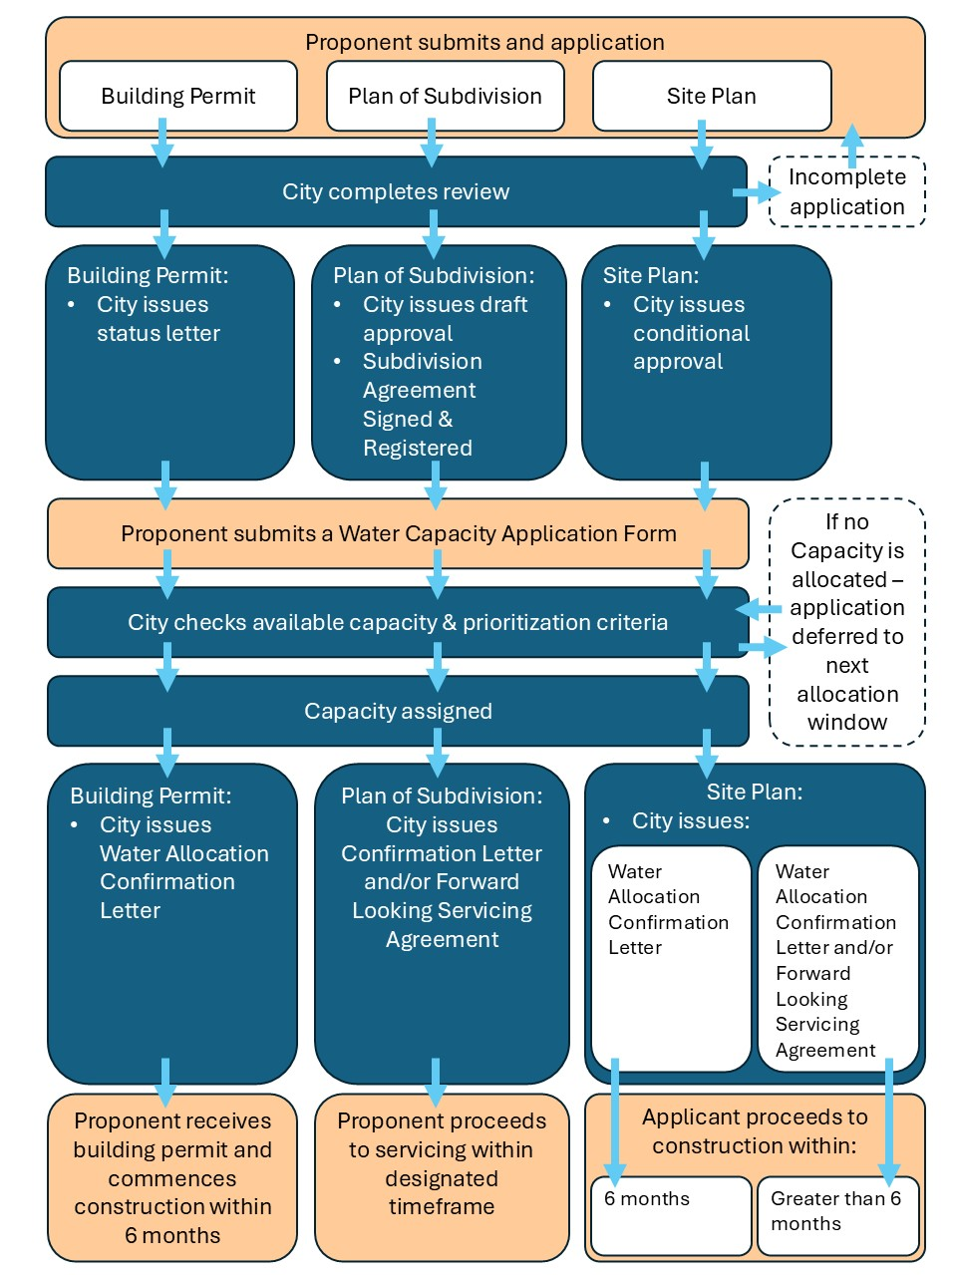

RELATED DOCUMENTS/LEGISLATION
Bill 185, Cutting Red Tape to Build More Homes Act, 2024
Development Charges Act, 1997,
About Affordable Housing in Canada, Canadian Mortgage and Housing Corporation, March 31, 2018.
Ontario Building Code Act, 1992, S.O. 1992, c. 23, as amended
Municipal Act, 2001, S.O. 2001, c. 25, as amended

Schedule A
Mannheim Water Service Area
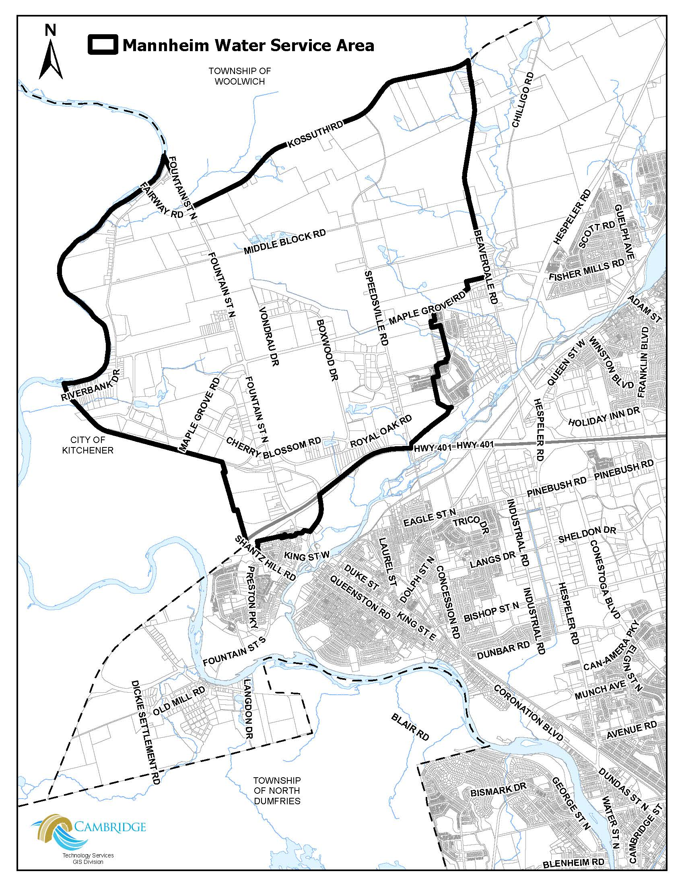

Schedule B
Water Allocation Prioritization Framework
Priority 1 – Essential Projects
Housing
- Affordable Housing being advanced by, or in partnership with, the City of Cambridge, the Region of Waterloo, Province of Ontario, Government of Canada, and/or an agency/provider
- Affordable Housing being advanced by, or in partnership with, a Not-For Profit organization or housing provider
- Housing projects with committed funding, prescribed deadlines, that meet Affordability criteria secured through an executed agreement with any of the following programs; Build Faster Fund, Housing Accelerator Fund, Canada Mortgage and Housing Corporation, Build Canada Homes, or any program that meets the City’s definition of Affordable Housing
- Housing projects with committed funding, prescribed deadlines, which are 40% more efficient than the National Building Code, including measurable water conservation measures, secured through an executed agreement with Canada Mortgage and Housing Corporation
- New or expanded not-for-profit co-op housing projects
- Long-term care facilities with confirmed funding or in-principle support from the Province of Ontario.
Public Uses
- Emergency services
- Public services or projects in the broader public interest
- Health facilities
Industrial, Commercial, Institutional (ICI) Development
- Regionally significant employment development with high concentration of jobs
Priority 2 – Priority Projects
Housing
- Market residential housing with an Affordable Housing component (at least 5% of the units are Affordable)
- Independent supportive living (ex. seniors housing)
- Small-scale projects (10 units or less) that had a building permit application filed prior to December 22, 2025
- Housing projects with committed funding, prescribed deadlines which meet Canada Mortgage and Housing Corporation’s Affordability criteria, secured through an executed agreement with Canada Mortgage and Housing Corporation
- New or expanded not-for-profit co-op housing projects
Industrial, Commercial, Institutional (ICI) Development
- Significant employment development with high concentration of jobs
All uses
- Development that is required to provide public infrastructure that will service areas of the City that are external to the development site
Priority 3 – Important Projects
Housing
- Purpose built market rental housing
- Market housing with purchase commitments (pre-sales, etc) prior to December 22, 2025
- Market housing with a development application filed prior to December 22, 2025
- Small scaled projects (less than 10 units)
Industrial, Commercial, Institutional (ICI) Development
- Employment development
Priority 4 – Development Projects
Housing
- Market housing without purchase commitments (pre-sales, etc) prior to December 22, 2025
- Project subject to a current development/planning application

Priority 5 – Emerging Projects
Housing
- Subdivision applications filed after December 22, 2025
ICI Development
- High Water Users
Other
- Projects relying on speculative or non-budgeted/non-funded water supply expansions

