
SCHOOL IMPROVEMENT PLAN FOR STUDENT ACHIEVEMENT AND WELL-BEING
UPDATED AS OF …
November 26, 2018
ELEMENTARY: Continuous Learning and Improvement – Ormiston PS
DATA
STUDENT ACHIEVEMENT |  | CONTEXTUAL/EQUITY OF OUTCOMES |  |  |  |  |  | ATTITUDINAL
Literacy – Reading and Writing  Numeracy |  | Ethnicity - % of Community Population  69.7% Not a Visible Minority  9.4% Black  7.2% South Asian  3.7% Filipino  2.7% Chinese  2% West Asian  1.5 % Multiple Visible Minorities  1.2 % Latin American  0.9% Arab  0.2% Japanese  Religious Affiliations - % of Community Population  68.6% Christian  22.5% No Religious Affiliation  4.5% Muslim  3.2% Hindu  0.5% Buddhist  0.4% Jewish  0.1% Sikh  Grade 6 -8 Language Spoken 2017-2018  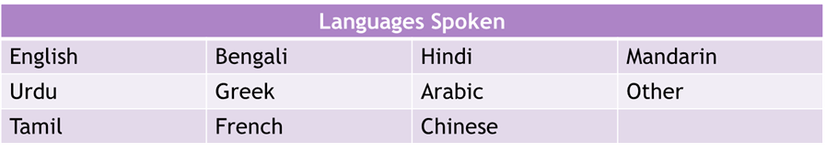  Special Education (2017-2018 data)  371 students: JK-8  61 IPRC - 16% (Slightly below DDSB Ave.)  23 of those 61 have an IPRC: Learning Disability  40 Gr. 3 students  8 IPRC - 20% (DDSB Ave.)  28 Gr. 6 students  11 IPRC (4 in PLP) - 39% of Grade 6s (Double the DDSB Ave.)  ESL  Attendance |  |  |  |  |  | 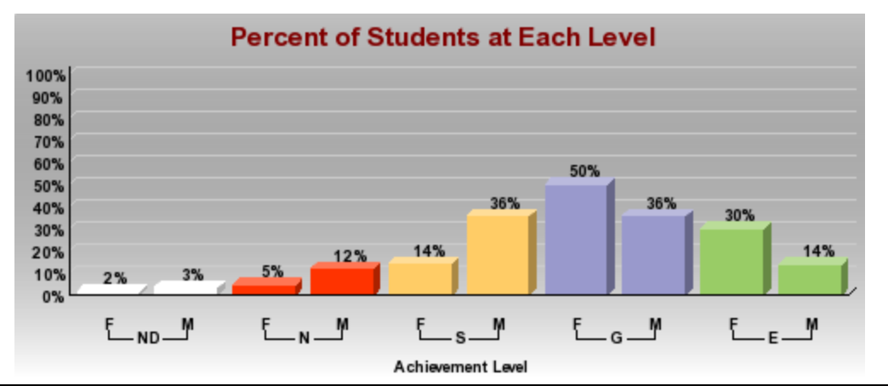  Primary Students Self-Regulation Female & Male T2 June 2018  Junior Students Self-Regulation Female & Male T2 June 2018  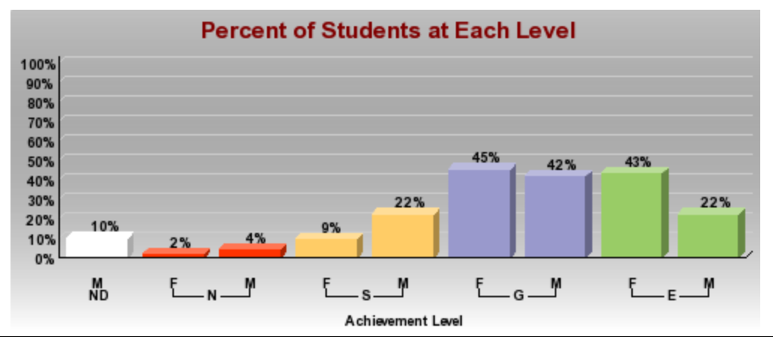  School Climate Survey  2018 – 66.8% of students feel supported when they are sad, anxious, hopeless, stressed, angry, confused, wired or some other unusual emotion for themselves  2016 – 71.4%; 2013 – 70.6%  2018 – 66.1% of students feel that others recognize when they are feeling sad, anxious, hopeless, stressed, angry, confused, wired, or some other unusual emotion for themselves; 2016 – 79.3%; 2013 – 64.7%  2018 – 89.1% of students feel that they support others when they see they are feeling sad, anxious, hopeless, stressed, angry, confused, wired or some other unusual emotion for themselves; 2016 – 89.6%; 2-13 – 91.4%  2018 – 78.5% of students know where to ask for help when they are feeling sad, anxious, hopeless, stressed, angry, confused, wired or some other unusual emotion for themselves; 2016 – 74.4%; 2013 – 72.2%  72.6% of students feel there is someone they can talk to about feeling sad, anxious, hopeless, stressed, angry, confused, wired, or some other unusual emotion for themselves; 2016 – 74%; 2013 – 75%
   |  | T2 R # Level 3 or 4
  Grade | Total # Students  (IEP) | Report Card  June 2018  Reading | Report Card June 2018  Writing
  1 | 1 | 23 (53%) | 23 (54%)
  2 | 5 | 23 (61%) | 18 (48%)
  3 | 10 | 27 (65%) | 26 (62%)
  4 | 3 | 27 (80%) | 27 (80%)
  5 | 7 | 34 (82%) | 30 (74%)
  6 | 7 | 16 (57%) | 15 (53%)
  7 | 7 | 33 (78%) | 32 (76%)
  8 | 7 | 28 (86%) | 27 (85%)
  Grade | # Spec. Ed | T 2 Report Card # Level 3 or 4
  Grade | # Spec. Ed | N | M | G | P & A | D | Avg
  1 | 1 | 32 (75%) | 38 (89%) | 26 (83%) | 32 (74%) | 27 (63%) | 76.8%
  2 | 5 | 21 (55%) | N/A | 33 (74%) | 26 (69%) | 27 (71%) | 67%
  3 | 10 | 33 (79%) | 24 (58%) | 37 (88%) | 37 (88%) | 39 (93%) | 81.2%
  4 | 3 | 27 (79%) | 25 (74%) | 30 (88%) | 29 (85%) | 25 (73%) | 79.8%
  5 | 7 | 35 (86%) | 37 (90%) | 33 (81%) | 37 (90%) | 33 (80%) | 85.4%
  6 | 7 | 18 (65%) | 13 (47%) | 29 (68%) | 20 (72%) | 19 (68%) | 64%
  7 | 7 | 27 (64%) | 31 (83%) | 35 (84%) | 28 (66%) | N/A | 74%
  8 | 7 | 28 (87%) | 27 (85%) | 29 (91%) | 28 (87%) | 22 (69%) | 84%
GOALS
LITERACY |  |  |  |  |  | NUMERACY
STUDENT LEARNING OUTCOMES |  |  | FROM % | TO % | # of students this represents | STUDENT LEARNING OUTCOMES |  |  |  | FROM % | TO % | # of students this represents
Primary Reading – EQAO results |  |  | 77 | 83 | 3 | PRIMARY MATH – EQAO results will increase |  |  |  | 58 | 75 | 7
primary writing – EQAO results |  |  | 70 | 80 | 4 | JUNIOR MATH – EQAO results will increase |  |  |  | 39 | 70 | 7
junior reading – EQAO results |  |  | 71 | 80 | 2 | intermediate students – gr 7 NUMBER SENSE AND NUMERATION:  students achieving above 70% |  |  |  | 68 | 70 | 1
junior writing – EQAO results |  |  | 82 | 85 | 2
intermediate students – gr 7 reading: students achieving above 70% |  |  | 83 | 90 | 2 | intermediate students – gr 8 NUMBER SENSE AND NUMERATION:  of students achieving above 70% |  |  |  | 93 | 95 | 1
intermediate students – gr 7 writing: students achieving above 70% |  |  | 80 | 85 | 2
intermediate students – gr 8 reading: students achieving above 70% |  |  | 93 | 95 | 1
intermediate students – gr 8 writing: students achieving above 70% |  |  | 90 | 95 | 1
ENSURING EQUITABLE OUTCOMES / IDENTIFIED SUB-GROUPS |  |  | FROM % | TO % | # of students this represents | ENSURING EQUITABLE OUTCOMES / IDENTIFIED SUB-GROUPS |  |  |  | FROM % | TO % | # of students this represents
Primary Reading for students with special education supports |  |  | 67 | 70 | 1 | Primary MATH for students with special education supports |  |  |  | 67 | 75 | 1
Primary writing for students with special education supports |  |  | 67 | 70 | 1 | JUNIOR MATH for students with special education supports |  |  |  | 40 | 75 | 2
junior Reading for students with special education supports |  |  | 40 | 70 | 2 | INTERMEDIATE STUDENTS – gr 7 NUMBER SENSE AND NUMERATION:  with special education supports |  |  |  | 57 | 75 | 1
junior writing for students with special education supports |  |  | 60 | 70 | 1
intermediate Reading for students with special education supports – gr 7 |  |  | 71 | 75 | 1 | INTERMEDIATE STUDENTS – gr 8 NUMBER SENSE AND NUMERATION:  with special education supports |  |  |  | 88 | 95 | 1
intermediate Reading for students with special education supports – gr 8 |  |  | 88 | 90 | 1
intermediate writing for students with special education supports – gr 7 |  |  | 71 | 75 | 2
intermediate writing for students with special education supports – gr 8 |  |  | 75 | 80 | 1
WELL-BEING FOCUS AND INITIATIVES:  Based on data informed school need using the (Aligned and Integrated Model from SMH-ASSIST)  Goal: support instructional strategies and structures that support well-being, inclusion and mental health  Commitments:  - Set school based/ classroom based norms for how we will treat and act with each others and self  - Identify students at risk emotionally/ socially and marginalized  - Maintain classroom practices, procedures and routines that promote safety, acceptance, inclusion and respectful behaviours  - Use inclusive and respectful language and examples of diverse families, gender neutral pronouns and a variety of sources, help students see themselves in their learning  - Use common language among staff that is consistent, strength based and non-stigmatizing  - Implement and refine self-regulation and social emotional learning strategies into daily teaching practices  - Assess students’ learning styles to identify themes and students with uncommon preferences, in order to determine which methods of instruction suit each students’ abilities  - Use of Community Circles and Restorative Practices and Self-Regulation programs in the classrooms and throughout the school |  |  |  |  |  | INTENDED EVIDENCE OF IMPACT:  Evidence of Impact: all students will have the opportunity to engage in daily practices and curriculum tasks that support their well-being and positive mental health  - Students will report increased sense of belonging on student climate survey  - Increased competency rating on the smh-ASSIST reflection tool  - Qualitative feedback from stakeholders of atmosphere and individual responses  - Quantitative feedback from student survey on equitable and inclusive outcomes for student sin grades 6, 7 and 8  - Increased number of students utilizing and experiencing success with WITS (walk away, ignore, talk away, seek assistance); increased number of students utilizing the zones of regulation and consistent language throughout the school with staff and students
STUDENT LEARNING NEED (Literacy and Numeracy)  Numeracy  - Apply thinking and application skills to effectively solve problems and demonstrate understanding of mutli-step problem solving tasks  - Select tools and strategies (including manipulatives and technology) to strengthen thinking skills with a focus on reasoning and proving through justification through mathematical discourse using mathematical terminology  - Have mathematical misconceptions/ gaps identified through classroom assessment and addressed through a focused and precise instruction (specific focus in Number Sense and Numeration and Measurement)  - Ongoing opportunities to receive and act upon descriptive feedback based on co-constructed learning goals and success criteria  Literacy  - Expand background knowledge and vocabulary to support reading comprehension, with a focus on skills of inferencing and making connections  - Use of personal background knowledge and other connections to justify the reasonableness of inferences drawn from texts  - Apply critical thinking skill of inferencing to determine the main idea of fiction and non-fiction texts (oral, written, media texts)  - Ongoing opportunities to receive and act upon descriptive feedback based on co-constructed learning goals and success criteria |  |  |  |  |  | EDUCATOR LEARNING NEED (Literacy and Numeracy)  Numeracy  - Balanced approach to programming (scope and sequence) and assessment across four categories of achievement, with a specific focus on deepening knowledge of the categories of thinking and application  - Talk moves to support thinking and application (with a focus on reasoning and proving)  - Selection of tools and strategies (technology and manipulatives) to support students in developing problem solving skills  - Content understanding for Number Sense and Numeration and Measurement  - Co-construction of Learning Goals, Success Criteria, Descriptive feedback connected to grade level curriculum content and four categories of achievement  Literacy  - Implementation of balanced approach to instruction (modelled, shared, guided and independent) to support student understanding of inferencing and extending understanding (making connections) with fiction and non-fiction texts  - Text selections and lesson structures to support Culturally Responsive and Relevant Pedagogy  - Co-construction of Learning Goals, Success Criteria, Descriptive feedback connected to grade level curriculum content and four categories of achievement
LITERACY/EQUITABLE OUTCOMES for Identified Student Groups |  |  |  |  |  | LITERACY/EQUITABLE OUTCOMES for Identified Student Groups
Proportional learning outcomes for identified in-risk student groups, with a focus on Learning Disabilities and English Language Learners |  |  |  |  |  | -differentiated instructional approaches with a focus on guided practice and guided interventions  -Use of technology to allow student access to tasks and information, deepen student learning and consolidation of concepts  -personalized learning goals, success criteria and descriptive feedback
NUMERACY/EQUITABLE OUTCOMES for Identified Student Groups |  |  |  |  |  | NUMERACY/EQUITABLE OUTCOMES for Identified Student Groups
Proportional learning outcomes for identified in-risk student groups, with a focus on Learning Disabilities and English Language Learners |  |  |  |  |  | -differentiated instructional approaches with a focus on guided practice and guided interventions  -Use of technology to allow student access to tasks and information, deepen student learning and consolidation of concepts  -personalized learning goals, success criteria and descriptive feedback
SEF INDICATOR | TARGETED EVIDENCE INFORMED STRATEGIES |  |  | LEVERAGING DIGITAL |  |  | TEACHER WILL: |  | STUDENT WILL:
Literacy  Assessment for, as and of Learning  1.4 – during learning timely, ongoing, descriptive feedback about student progress is provided based on student actions and co-constructed success criteria  Curriculum, Teaching and Learning  4.5 – instruction and assessment are differentiated in response to student strengths, needs and prior learning  4.6 – resources for students are relevant, current, accessible, inclusive and monitored for bias  Student Engagement  3.3 – students are partners in dialogue and discussions to inform programs and activities in the class and the school that represent the diversity, needs, and interests of the student population. | 1. Balanced literacy programming (modeled, shared, guided and independent approaches).  2. Co-construction of interactive learning walls (“learning loop”) with clearly articulated learning goals, success criteria, exemplars, and anchor charts used to inform timely and ongoing descriptive feedback to students.  3 .Literacy instruction of strategies and forms in all content areas to strengthen connections among reading, writing, oral and media literacy. |  |  | -using digital resources, students are supported in accessing a variety of texts, both fiction and non-fiction, that represent multiple viewpoints and perspectives  -teachers create opportunities for students to create new knowledge, accessing multiple relevant resources through technology and using technology, when appropriate to create and communicate new and innovative solutions  - students use technology to seek feedback that informs and improves their practice, for example using the commenting features in collaborative docs to provide peer and teacher feedback |  |  | - scaffold student learning through a balanced approach (modeled, shared, guided, independent approaches)  -provide cross –curricular inquiry learning opportunities and approaches supported through effective use of technology  -co-construct a supportive and engaging learning environment with students  -use prompts, questions and talk moves to facilitate HOT skills  -co-construct with students, interactive learning walls (learning goals, success criteria, anchor charts, exemplars)  -provide timely and specific descriptive feedback to students with ongoing opportunities for students to act upon feedback  -engage students in self- assessment  -engage in Faces of the Data Case Conferences, implement targeted strategies, monitor impact through SMART chart monitoring  - engage in professional learning related to SIPSAW and personal learning needs  -engage in moderation of student tasks and responses using feedback |  | -demonstrate critical thinking skills (inferring and extending understanding by making connections) when reading and writing texts  -engage in learning approaches and consider school, community, and global issues, with a focus on equity and inclusion  -co-construct and create classroom learning resources of LG, SC, anchor charts and exemplars  -set goals for own learning and act upon descriptive feedback received from peers and teachers  -answer the following 5 key questions when prompted by staff:  What are you learning?  How are you doing?  How do you know?  Where can you go for help?  How can you improve?
Numeracy  Assessment for, as and of Learning  1.4 – during learning timely, ongoing, descriptive feedback about student progress is provided based on student actions and co-constructed success criteria  Curriculum, Teaching and Learning  4.5 – instruction and assessment are differentiated in response to student strengths, needs and prior learning  4.6 – resources for students are relevant, current, accessible, inclusive and monitored for bias  Student Engagement  3.3 – students are partners in dialogue and discussions to inform programs and activities in the class and the school that represent the diversity, needs, and interests of the student population | 1. Balanced numeracy programming (modeled, shared, guided and independent approaches).  2. Use of manipulatives (“thinking tools”) and representations to support student communication of math thinking through conversations, observations and products.  3. Co-construction of interactive learning walls (“learning loop”) with clearly articulated learning goals, success criteria, exemplars, and anchor charts used to inform timely and ongoing descriptive feedback to students. |  |  | -the physical environment is laid out in a way that facilitates peer-to-peer collaboration. Students have the opportunity to work in partners, small groups, or interdependent large groups.  -students communicate complex ideas clearly and effectively by using a variety of digital objects such as visualizations, models or simulations  -timely, descriptive feedback is provided for all student and digital tools are leveraged to support frequent feedback through structures such as self-grading, self-reflection and peer-feedback in addition to meaningful teacher-provided feedback |  |  | -scaffold student learning through a balanced approach (modelled, shared, guided, independent approaches) and scope and sequence planning  -co-construct a supportive and engaging learning environment with students  -embed multi-step and open/ parallel tasks in all learning cycles  -use prompts, questions, and talk moves to build higher level thinking skills  -ensure tools and representations support problem solving skills  - provide timely and specifically descriptive feedback to students with ongoing opportunities to act upon feedback  -engage in professional learning related to school improvement plan and personal learning goals  -engage in Faces on the Data Case Conferences, implement targeted strategies and monitor impact using SMART chart monitoring |  | -scaffold to independence the application and thinking skills when solving multi-step tasks and open tasks  - use a variety of tools and strategies to demonstrate reasoning and proving  -demonstrate improvement in number sense and numeration and measurement  -co-construct /create learning resources (LG, SC, anchor charts, exemplars) to support learning  -communicated math thinking using a range of manipulatives and representations within and across all math strands  -set goals for their own individual learning and act upon descriptive feedback received from peers and teachers  - use content specific math vocabulary when answering the 5 key questions:  What are you learning?  How are you doing?  How do you know?  Where can you go for help?  How can you improve?

Aligning Principal Leadership and Monitoring
MAPPING OUT THE YEAR
Literacy Numeracy Well-Being Equity and Inclusion Leveraging Digital
LITERACY GOAL: If we implement a balanced approach to instruction (modelled, shared, guided and independent) to support student understanding of inferencing and extending understanding (making connections) with fiction and non-fiction texts with CRRP then students will be able to expand upon their background knowledge and vocabulary to support reading comprehension, with a focus on skills of inferencing and making connections. |  |  |  |  |  | NUMERACY GOAL: If we use a balanced approach to programming and use of assessment tools across all 4 categories of achievement chart, utilizing selection of tools and strategies in number sense and numeration and measurement by co-constructing LG, SC, DF connected to grade level curriculum content then students will apply thinking and application skills effectively to solve problems and demonstrate understanding of multi-step problem solving tasks
 | August | September | October | November | December |  | January | February | March | April | May | June
Director’s Meeting | Meeting 28th |  | Meeting 16th | Meeting 13th | Meeting 11th |  | Meeting 15th | Meeting 12th | Meeting 26th | Meeting 16th | Meeting 7th  BIP/SIP | Meeting 11th
Family of Schools | Meeting 28th | Meeting – Sept 20th | Meeting – Oct 25th | Meeting –  Nov 22nd  SSA | Meeting – Dec 20th |  | Meeting –  Jan. 24th | Meeting –  Feb 21st  SSA | Meeting –  Mar 5th | Meeting –  Apr 18th | SSA | Meeting –  June 20th  SIP Moderation  last week of June/  first week of July
Staff Meetings  - Division & Department | August 30th | Sept 4th | Oct 1st | Nov 5th | Dec 3rd |  | Jan 7th | Feb 4th | Mar 4th | Apr 1st | May 6th | June 3rd
School Improvement Team | August 30th  ^{Establish SIT} | Sept 21st | Oct 25th | Nov 27th |  |  | Jan 29th | Feb 26th |  | Apr 30th | May 28th
Principal Monitoring  - Instructional Rounds/Walking to Learn  - Critical Conversations |  | Prioritize Daily Walk to learn focused on common commitments  Continue to use the 5 questions with students during walk to learn and provide feedback to teachers based on student responses  Focus on math blocks and students’ mathematical thinking and discourse | Prioritize Daily Walk to learn focused on common commitments  Continue to use the 5 questions with students during walk to learn and provide feedback to teachers based on student responses  Focus on math blocks and students’ mathematical thinking and discourse | Prioritize Daily Walk to learn focused on common commitments  Continue to use the 5 questions with students during walk to learn and provide feedback to teachers based on student responses  Focus on math blocks and students’ mathematical thinking and discourse | Prioritize Daily Walk to learn focused on common commitments  Continue to use the 5 questions with students during walk to learn and provide feedback to teachers based on student responses  Focus on math blocks and students’ mathematical thinking and discourse |  | Prioritize Daily Walk to learn focused on common commitments  Continue to use the 5 questions with students during walk to learn and provide feedback to teachers based on student responses  Focus on math blocks and students’ mathematical thinking and discourse | Prioritize Daily Walk to learn focused on common commitments  Continue to use the 5 questions with students during walk to learn and provide feedback to teachers based on student responses  Focus on math blocks and students’ mathematical thinking and discourse | Prioritize Daily Walk to learn focused on common commitments  Continue to use the 5 questions with students during walk to learn and provide feedback to teachers based on student responses  Focus on math blocks and students’ mathematical thinking and discourse | Prioritize Daily Walk to learn focused on common commitments  Continue to use the 5 questions with students during walk to learn and provide feedback to teachers based on student responses  Focus on math blocks and students’ mathematical thinking and discourse | Prioritize Daily Walk to learn focused on common commitments  Continue to use the 5 questions with students during walk to learn and provide feedback to teachers based on student responses  Focus on math blocks and students’ mathematical thinking and discourse | Prioritize Daily Walk to learn focused on common commitments  Continue to use the 5 questions with students during walk to learn and provide feedback to teachers based on student responses  Focus on math blocks and students’ mathematical thinking and discourse
Faces on the Data | Identify Inrisk, marginalized student(s) | Pre-assessment data collection for FOD and informing IEP development | October 1-5th BAS/ PRIME to office  October 9-11th | Grade 3 & 6  Nov 6th | Dec 4-6th |  | Grade 3 & 6  Jan 10th | Feb 5-7th | Grade 3 & 6  Mar 5th | Apr 2-4th
School Self-Assessment (SSA) |  | SEF Application  Which school practices and structures are supporting limited progress | Superintendent Visit Oct 30th  #1 | SSA Due November 30, 2018 |  |  |  |  | SSA Due  March 7, 2019 |  | SSA Due  May 31, 2019
School-Wide Consolidation (EQAO, OSSLT Plan) | Review EQAO/ Report Card Data | Review SIPSAW  Share EQAO Plan | Oct 3rd  Grade 3 & 6
Professional Learning  - BCI |  |  | Oct 9 FDK AM & PM BCI | Nov 12 FDK AM & PM BCI  Nov 2 BCI P/J | Dec 3 BCI J/P |  | Jan 10 FDK AM & PM BCI  Jan 31 BCI P/J | Feb 11 FDK AM & PM BCI | Mar 19 BCI J/P
Professional Learning  - Workshops/Training  - Projects/Initiatives |  | Community Circles  Literacy  Equity | Manipulatives  EQAO  Equity  ESL; ELL | Literacy  Equity | Literacy  Equity
Budget/Expenditures

