Municipality of Dysart et al

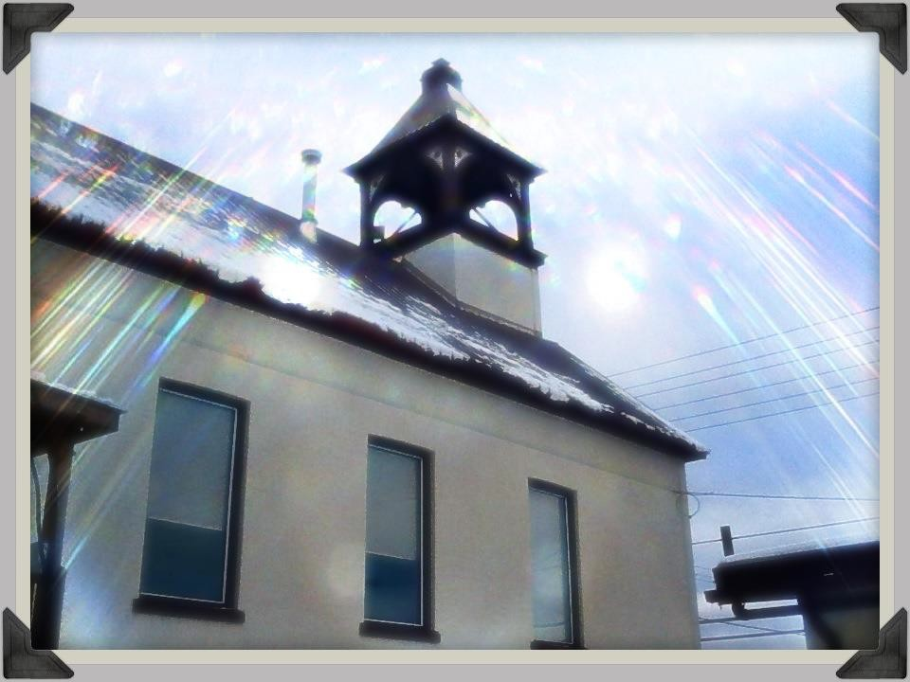

CONSERVATION AND DEMAND MANAGEMENT PLAN 2025 - 2030

October 2025 - Municipality of Dysart et al

- Commitment 1
- Organizational Understanding 2
- Resources Planning 5
- Projects Execution 5
- Review 6
- Evaluation Progress 6
- Energy Consumption and GHG Emissions 7
- Programs 11
- Processes 11
- Identified Projects 12

Commitment

Declaration of Commitment:
Dysart et al will continue to allocate the necessary resources to implement a strategic energy management plan that will reduce energy consumption and its related environmental impact.

Vision:
Dysart et al will exercise stewardship in its use of finite energy resources to reduce energy consumption and associated carbon footprint, demonstrate leadership, and enhance the overall quality of life in the community.

Goals:
To continuously improve the energy efficiency of the Municipality’s facilities and processes in order to reduce operating costs, energy consumption and the associated greenhouse gas emissions, while providing education and awareness opportunities to the broader community throughout the process.

Overall Target:
The Municipality will make every effort to reduce consumption of fuels and electricity in all operations by an average of 1.5% per year between now and 2030.

Objectives:
The culture of conservation within the Municipality will be maintained with the goal to:

- Reduce Greenhouse gas emissions and ensure the wise use of resources

- Enhance fiscal accountability through savings and cost avoidance leading to both direct and indirect savings

- Demonstrate energy management leadership and commitment within the Municipality of Dysart et al and the broader community

- Demonstrate sound operating and maintenance practices
- Provide an ongoing forum for discussion within the Municipality of Dysart et al on energy management to explore new ideas and trends

Organizational Understanding

Summary of Current Energy Consumption, Cost and Green House Gas Emissions:
Since 2011, we have monitored energy consumption in 29 municipal facilities in the Municipality of Dysart et al. These facilities range from sewer pump houses to solar panel connections to community centres. The total area between these facilities is 89,196 square feet.
In 2011, the total annual electric energy consumption in municipal operations was 1,680,641 kWh, total fuel oil consumed at 45,628 litres and propane at 32,800 litres for both heating and cooling processes. Our Green House Gas emissions totalled 309.54 tonnes/year.
In 2012, the total annual electric energy consumption in municipal operations was 1,483,415 kWh, total fuel oil consumed at 30,098 and propane at 46,040 litres for both heating and cooling processes. It should be noted that the fluctuation between propane and oil would relate to changing of heating system at Roads garage from oil to propane. Our Green House Gas emissions totalled 295.74 tonnes/year.
In 2013, the total annual electric energy consumption in municipal operations was 1,674,456 kWh, total fuel oil consumed at 35,709 litres and propane at 62,582 litres for both heating and cooling processes. Our Green House Gas emissions totalled 321.39 tonnes/year.
In 2014, the total annual electric energy consumption in municipal operations was 1,868,053 kWh, total fuel oil consumed at 34,618 litres and propane at 71,949 litres for both heating and cooling processes. Our Green House Gas emissions totalled 280.30 tonnes/year.
In 2015, the total annual electric energy consumption in municipal operations was 1,844,895 kWh, total fuel oil consumed at 31,265 litres and propane at 77,384 litres for both heating and cooling processes. Our Green House Gas emissions totalled 279.57 tonnes/year.
In 2016, the total annual electric energy consumption in municipal operations was 1,910,961 kWh, total fuel oil consumed at 31,086 litres and propane at 80,345 litres for both heating and cooling processes. Our Green House Gas emissions totalled 276.77 tonnes/year.
In 2017, the total annual electric energy consumption in municipal operations was 1,784,613 kWh, total fuel oil consumed at 24,825 litres and propane at 81,107 litres for

both heating and cooling processes. Our Green House Gas emissions totalled 223.75 tonnes/year.
2018 Data unknown
In 2019 the total annual electric energy consumption in municipal operations was 1,904,652kWh, total fuel oil consumed at 28,564.50 litres and propane at 98,812.5 litres for both heading and cooling processes. Our Green House Gas emissions totalled 438 tonnes/year.
In 2020 the total annual electric energy consumption in municipal operations was 1,398.575kWh, total fuel oil consumed at 28,510.9 litres and propane at 92,727,17 litres for both heating and cooling processes. Our Green House Gas emissions totalled 386 tonnes/year.
In 2021 the total annual electric energy consumption in municipal operations was 1,432,166.4kWh, total fuel oil consumed at 1,090 litres and propane at 3,052.6 litres for both heating and cooling processes. Our Green House Gas emissions totalled 203 tonnes/year.
In 2022 the total annual electric energy consumption in municipal operations was 1,823,852.7kWh, total fuel oil consumed at 901.2 litres and propane at 3,351.9 litres for both heating and cooling processes. Our Green House Gas emissions totalled 147 tonnes/year.
In 2023 the total annual electric energy consumption in municipal operations was 1,827,425.9kWh, total fuel oil consumed at 871.2 litres and propane at 3,028.5 litres for both heating and cooling processes. Our Green House Gas emissions totalled 146 tonnes/year.
In 2024 the total annual electric energy consumption in municipal operations was 1,833,210.1, total fuel oil consumed at 841 litres and propane at 2,691.3 litres for both heating and cooling processes. Our Green house gas emissions totalled 146 tonnes/ year.

Renewable Energy Utilized or Planned:

The Municipality of Dysart et al aspires to show leadership in the promotion and development of renewable energy systems that are compatible with the corporate asset management and land use planning objectives. Dysart et al was proactive with the development of a process to manage public requests for support for FIT applications in a timely manner.

Prior to announcements of energy reporting requirements, Dysart et al had investigated the potential to develop alternative and renewable energy systems through the commissioning of a feasibility study by Clean Development Group titled “Introducing the Integration of Clean Energy Systems”. Solar panel technology was employed on the 4Cs building to supplement power to the Museum attempted the use of passive solar heat.

Past Energy Initiatives:

The Municipality of Dysart et al has implemented several energy reducing initiatives in the past including the commissioning of the Clean Energy study and the Ainsworth Energy Conservation Proposal, which considered five municipal structures for energy conservation improvements. These documents remain a relevant part of this process from the perspective of providing additional background material about structures and heating systems and several outstanding valid recommendations that can be reviewed and considered as ‘projects’ as we work through individual building audits. We have the following reports and studies available at the municipal office upon request:

- Renewable Energy Feasibility Study – Clean Development Group
- Preliminary Energy Conservation Proposal – Ainsworth Inc.
- Hot2000 Building Audit Report for Sewage Plant Lab
- RETScreen 4 Building Audit Report for Municipal Building

A 2010 remodel of the museum saw the addition of insulation in the walls and in 2013 the requirement for a new roof, brought the benefit of additional insulation value as well.

In 2012, the arena ice surface was rebuilt and additional dressing rooms were created. During the upgrades many energy saving changes were made such as the installation of high efficiency equipment such as compressors, soft start motors, infrared ice temperature controllers, hot water heaters, dehumidification systems, lighting, kitchen appliances and shower heads. New insulated exit and overhead doors were also added. In 2013, the Parks Department removed several unused hydro connections that were no longer required.

During earlier years of the plan, our Environment and Climate Change Committee demonstrated the design and build of solar heated fish huts. This was integrated as a building project for the Haliburton High School Environmental program students to raise funds to sustain their program. A video was created to profile this and other environmental initiatives undertaken by our municipality.

Our Environment and Climate Change Committee also participated in two “Green Living Tours” showcasing the application of alternative energy in both residential and commercial projects. In 2014, the Committee also created a short educational video regarding sustainable building design in a local cottage context that profiled local renewable energy providers.

From 2011 to present time, the Environment and Climate Change Committee has undertaken an energy conservation study using a cottage as a test case. We use this information on our website and at trade shows to demonstrate simple changes that can be made to realize significant savings. “Conserve – A Cottage Story” is now one of our educational videos accessible through our website.

In the sewage plant, variable frequency drives have been installed to reduce energy consumption in the past two years.

Streetscape upgrades included the installation of new LED street and park lighting. In 2014, solar lights were installed in Rotary Park. A main street grant in 2018 saw the addition of solar lights along paths in Head Lake Park.

Museum Lights have been changed to LED and motion sensors have been installed and the Municipal Office lights were all changed out as Part of Hydro One’s Save on Energy Program. This was also completed at the Arena and Roads Department simultaneously.

At the landfill in Kennisis Lake, a new attendant building was constructed to be energy efficient and a new propane heater was installed. In 2017, a new shed was also built at Haliburton Landfill for energy efficiency. In 2025 Harcourt Landfill replaced their office space/shed, better conserving propane.

In 2017, our Council Chambers was outfitted with new LED lights. In 2018, we completed an addition on our municipal office and automatic shut off lights were installed for energy conservation.

A new municipal office parking lot was built in 2018 and outfitted with LED lights.

In 2025 a new attendant shed was constructed at the Harcourt Landfill to be energy efficient and better insulate the workspace.

Resources Planning

Energy Supply Management:

Electricity is supplied by Hydro One

Propane is supplied by multi-facility tender by local suppliers

Oil is supplied by MacEwen

Energy Use Management:
The Finance Department has been responsible for tracking utility and hydro costs for purposes of reporting energy consumption and greenhouse gas emissions. Department Heads monitor their hydro usage for anomalies as well. Tenders have been issued for propane and fuel for the majority of facilities for purposes of containing fuel costs.

Projects Execution

Municipal Level:
Dysart et al will carry out the required development of business procedures and communication programs and implement them methodically according to the planned time lines within the resource constraints that apply. The administration and implementation of this plan will be responsibility of the C.A.O. with the support of the Environmental Coordinator, however, since everyone uses energy in their daily activities, it will also be the responsibility of all Municipal staff to be aware of their energy use and work towards conservation. Through staff engagement, staff will be able to see the results of their efforts, and benchmark between corporate facilities and against general industry standard

Asset Level:
Dysart et al will use department and facility management representatives to facilitate the implementation of facility level business procedures and communication initiatives, including energy performance reporting.

In order to sustain a corporate culture of conservation, staff must be engaged in an effective awareness and education program. Although facility management staff have the lead responsibility in ensuring Municipal facilities operate efficiently, all Municipal staff should be familiar with and utilize energy efficient measures where possible. In addition, any facilities requiring rehabilitation, renewal and/or replacement will incorporate energy saving strategies where possible.

Review

Energy Plan Review:
Senior Management and Council will review and evaluate Dysart et al’s energy plan, revising and updating it as necessary, but at least on an annual basis.

Evaluation Progress

Energy Consumption:

The Municipality’s energy consumption in 2012 was reduced to 1,483,415 kWh per year from 2011 levels of 1,680,641 kWh per year.
During 2012, the arena underwent 9 months of construction which impacted fuel and electricity due to a combination of construction heating and shorter ice period.

During the winter of 2013-2014, we experienced very low temperatures for long durations which will also have an impact on figures as we try to match our conservation efforts with increased fuel usage. Although we realize that we are not unique in this regard in Ontario, it is worth noting as we work through the evaluation process on an annual basis.

At the sewage plant, there was a 3.3% reduction in hydro consumption due to 3.8% reduction of influent flows.

At the roads garage, we replaced the furnace oil heating system with propane heating system in the fall of 2011 resulting in propane as the sole heating source.

In 2015, there was a spike in Hydro usage at the fire hall due to a malfunctioning oil furnace which required the use of electric heat.

Solar lights were installed in our park privies, but unfortunately did not provide sufficient light. They were swapped out to LED lights in 2021.

In 2018, extra fuel was required at the museum due to a malfunctioning heating system which has now been repaired.

In 2022, two garage doors at the Roads Department Garbage were replaced, reducing heating costs

In 2024 two oil furnaces at the Museum were replaced with two propane heat pumps reducing fuel consumption

In 2024 sensor lights were installed at the Harcourt Rink with a thirty minute timer, a reduction in energy consumption from previous use of the lights continuously running.

In 2024 solar lights were installed at Glebe Park.

In 2025 the oil furnace for the Canoe FM building were changed to a high efficiency heat pump.

In 2025 a new timer was installed at the tennis courts to turn out lighting 30 minutes after being pressed to save energy.

In 2025 the library had its mercury vapor lights swapped to high efficiency LED lights

Energy Consumption and GHG Emissions
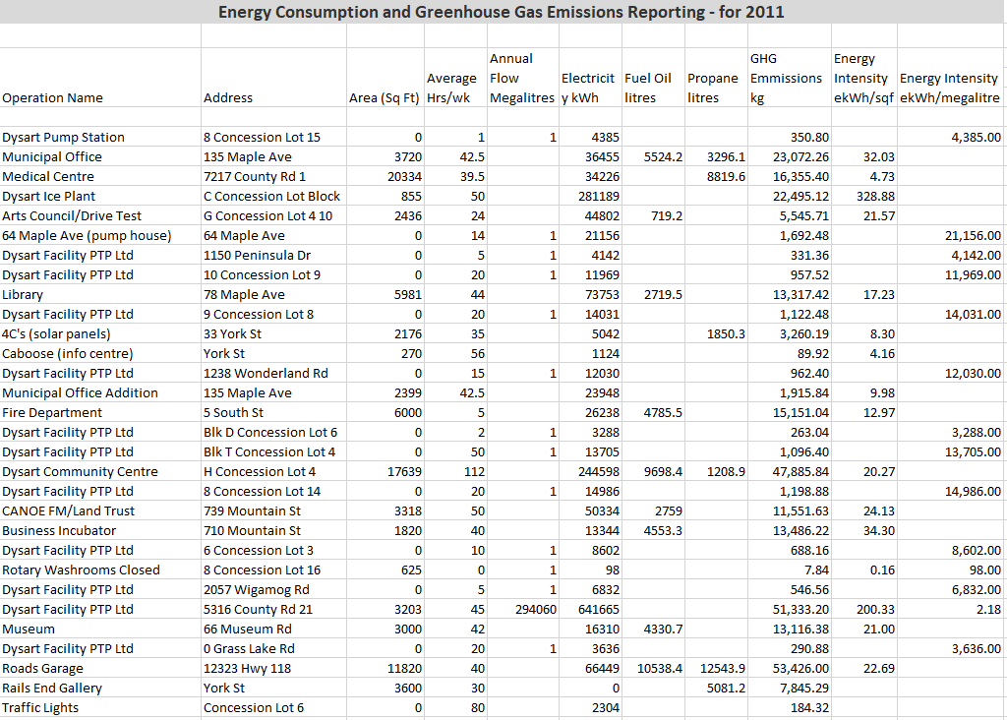

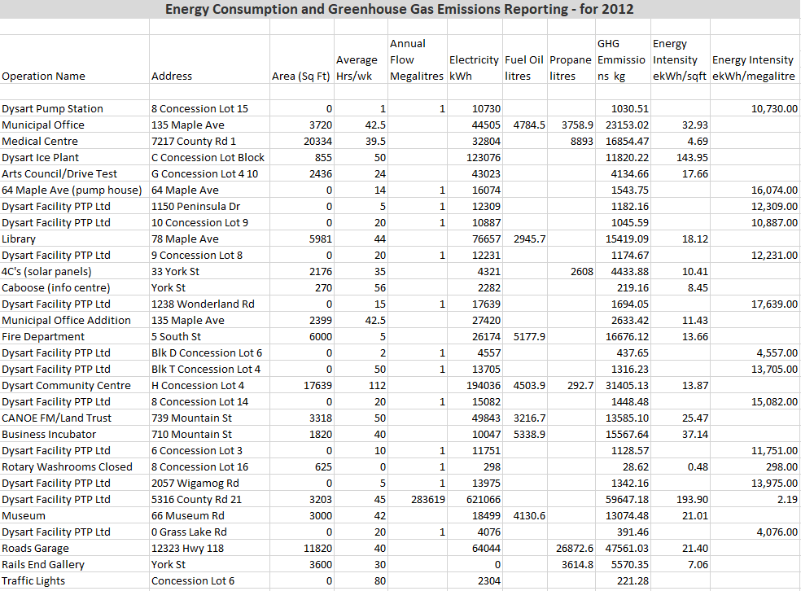
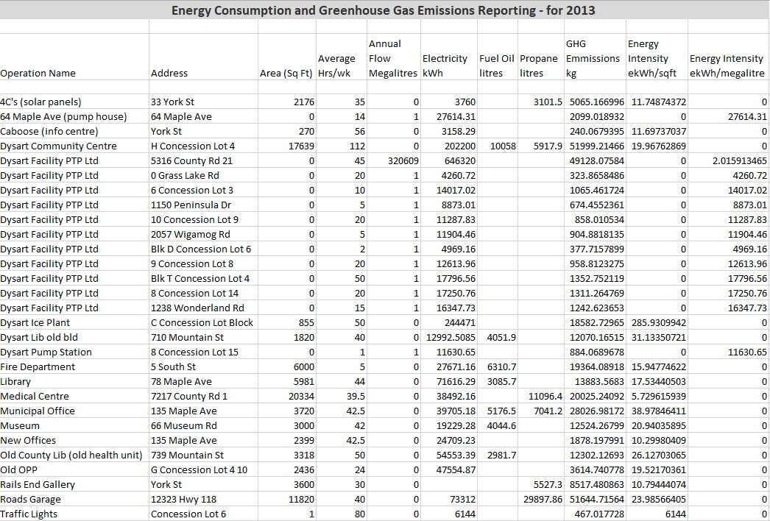

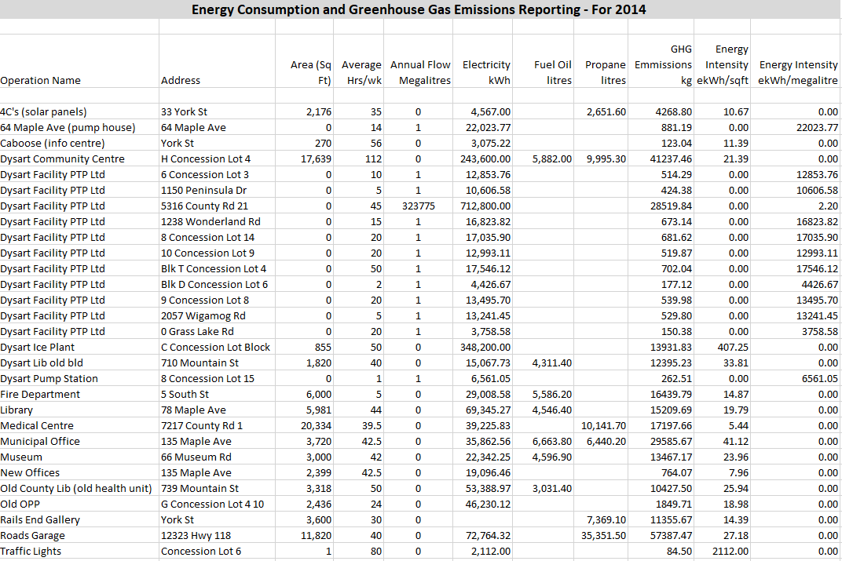
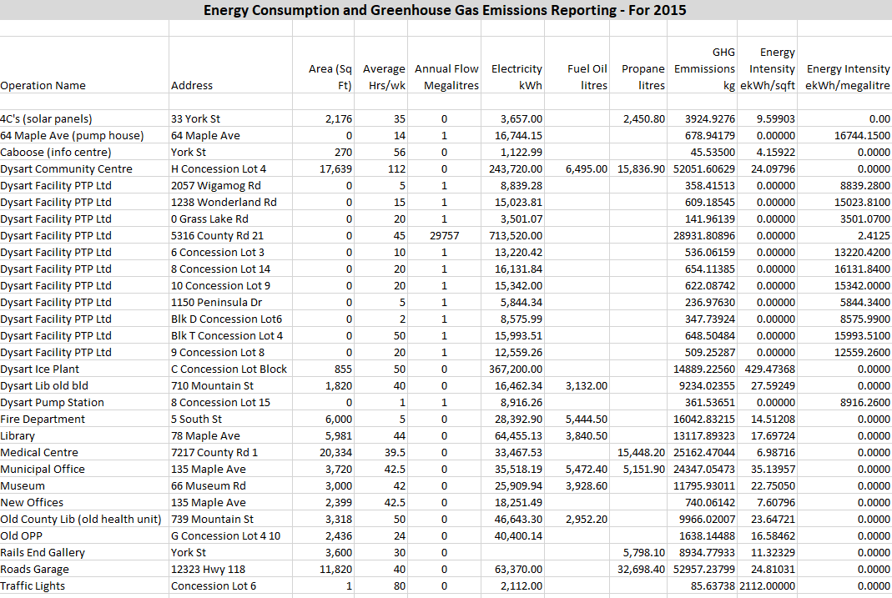

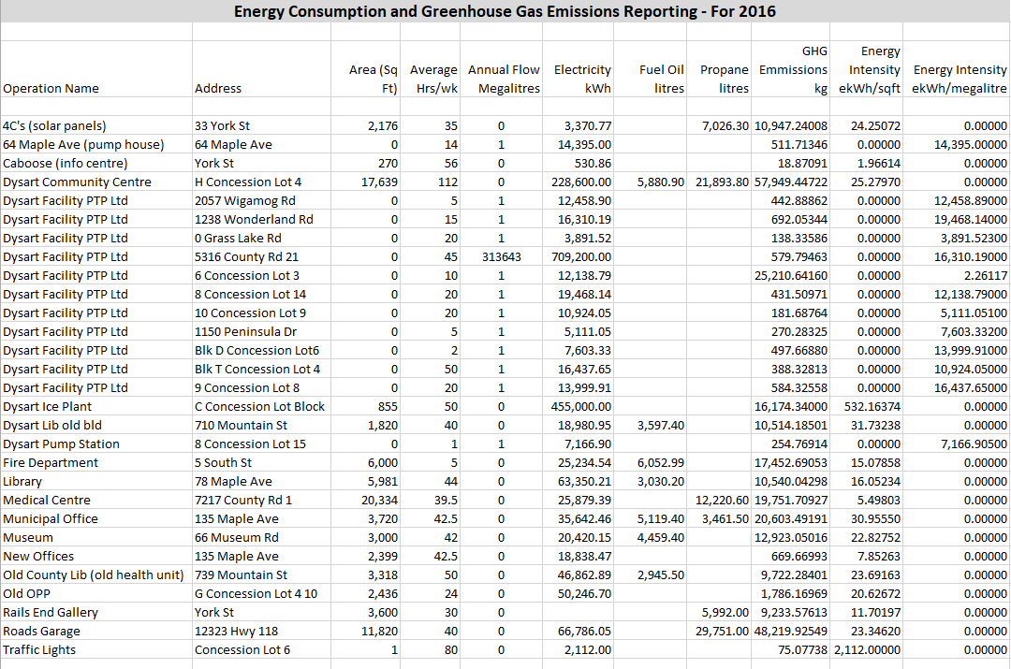
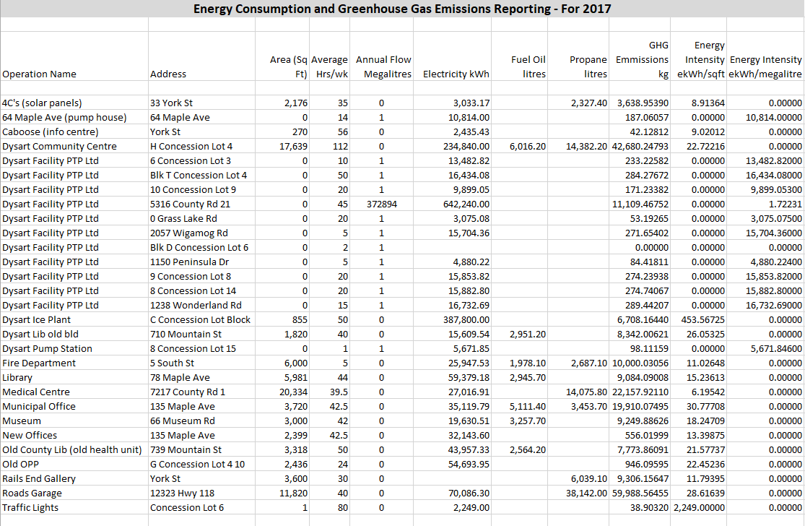

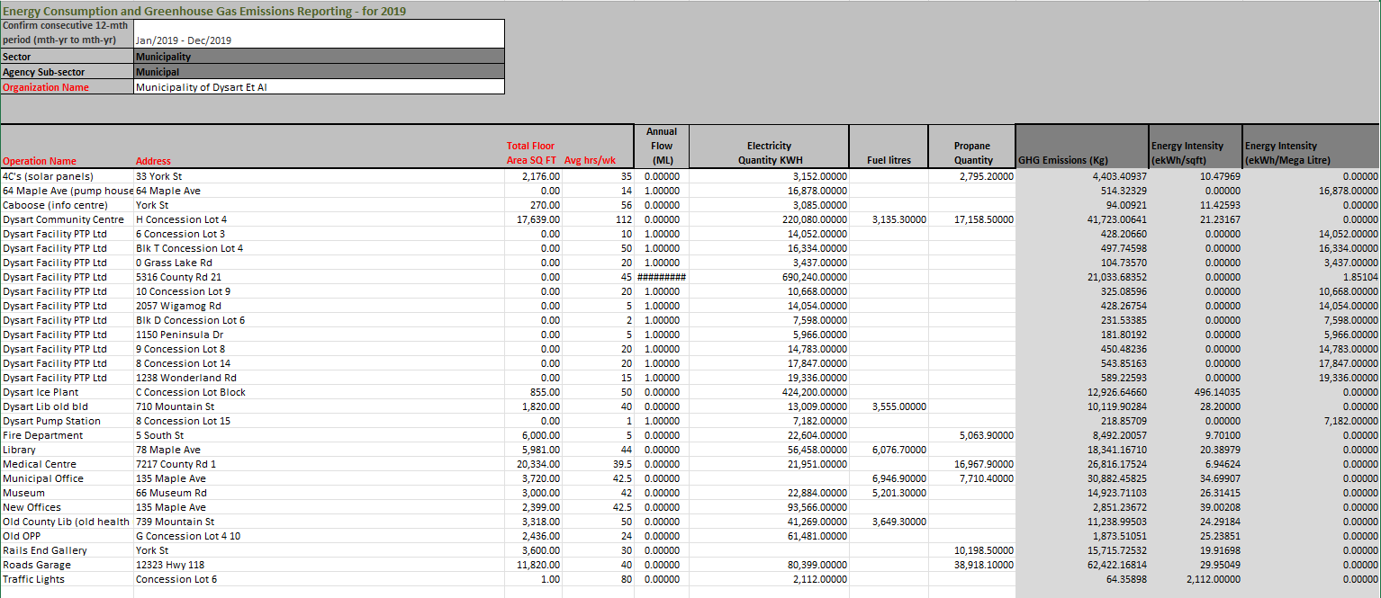

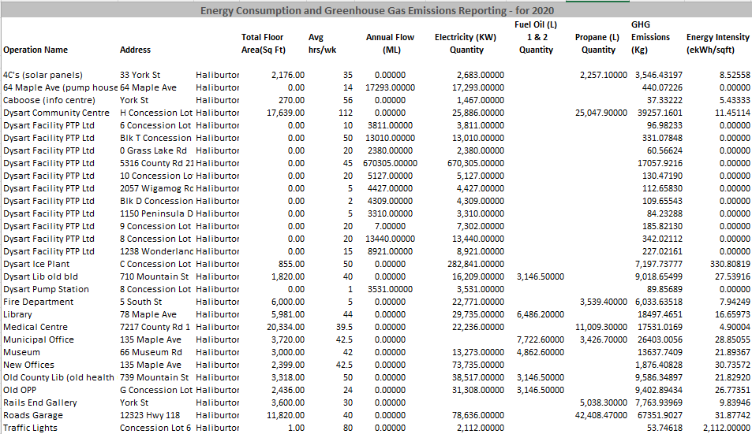

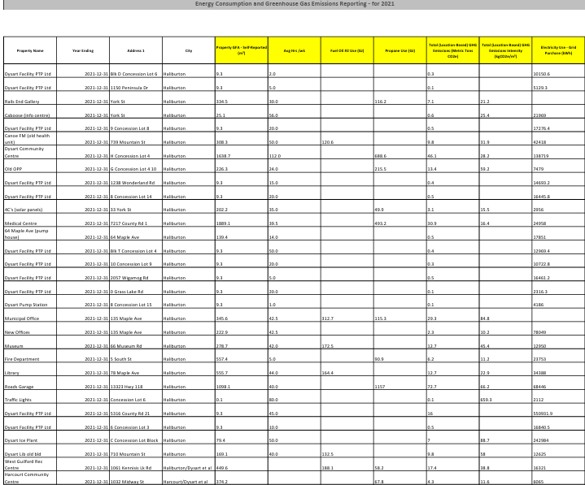

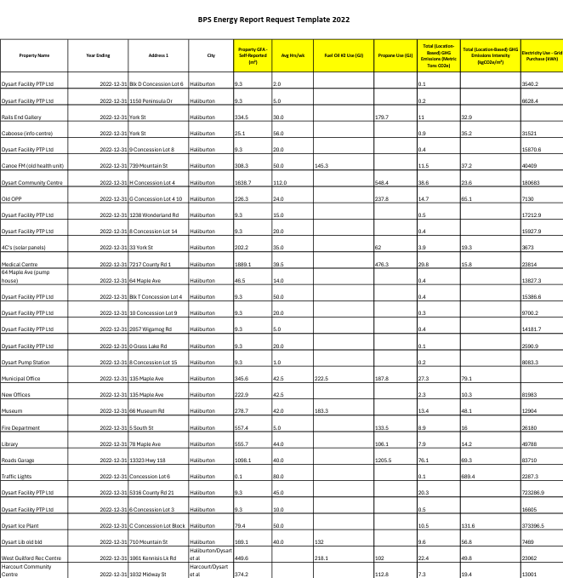

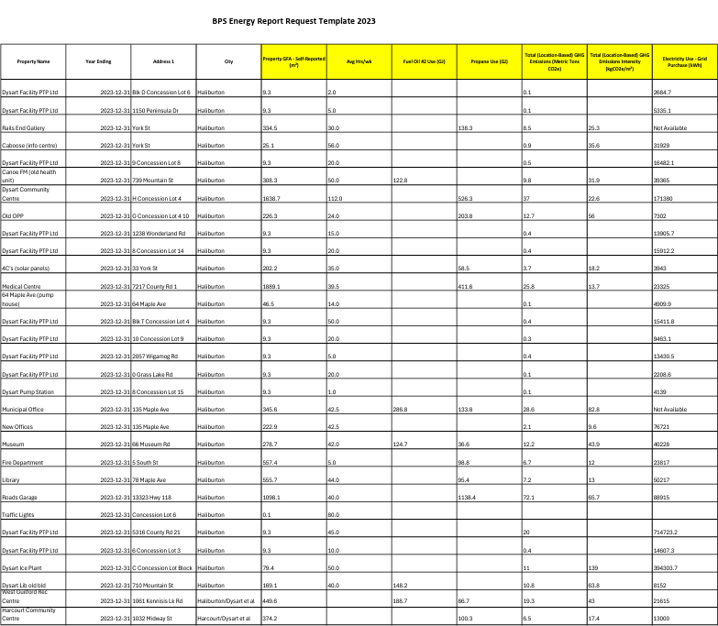

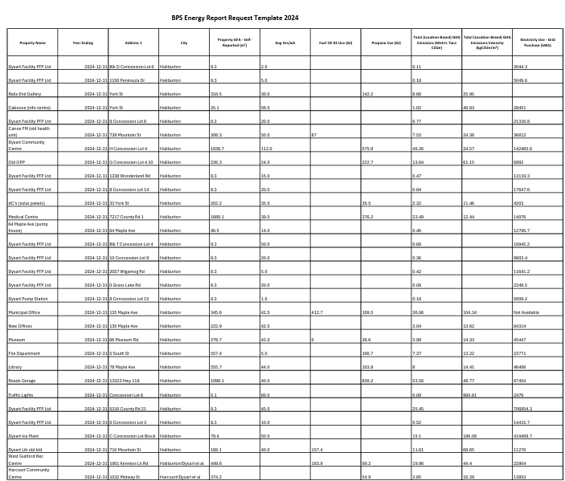

Programs

Actions | Status/Comments
Increase Energy Awareness by adding as an item to management team agendas. | Active.
Encourage employee participation by inviting employees from all departments to recommend ideas to reduce energy. | Active - Staff have been asked to submit comments with regard to programs, process and projects and the results have been included here.
Engage in Energy Accounting by ensuring that monthly utility usage and costs are monitored to identify trends and to emphasize anomalies to better  predict future usage requirements. | Active.
Efficiency Standards will be developed to identify and implement temperature regulations for each building to include standards for indoor temperatures for occupied and unoccupied space and hot water temperature. | Ensure thermostats or timers are set appropriately for season and hours of operation. It is important to note that we are  currently experiencing technical issues with our new furnace in the municipal office.
Asset purchases will be subject to consideration of energy use ratings as long as the primary function of the equipment is sufficient. | Active: e.g. New Energy Star rated photocopier purchased in 2014 for Municipal Building.
A Lights Out strategy will be developed to encourage staff to turn off lights in rooms that aren’t in use continuously such as kitchens and bathrooms or in rooms that are well lit with natural daylight. | Consider motion sensors and timers. Our new municipal office addition has automatic shut off lights and new areas of our arena have  automatic lights. Our museum is shutting out their lights between visitors.
Hold an Annual Energy Lunch and Learn for staff and council to review the ongoing requirement for energy conservation and demand management and to highlight efficiencies achieved through employee
participation.
Create a Fresh Air Campaign and consider shutting down air conditioning and heating systems and opening windows and doors when the temperatures
are conducive.
Develop a light bulb inventory and determine replacement wattage required to change out lights to more efficient versions as they stop functioning | Ongoing.
Review options with staff to conserve energy with routine office equipment by utilizing power bars and timers to shut down all computers, printers, adding machines, etc. at the end of the day to reduce  phantom loads. | Ongoing.

Processes

Actions | Status/Comments
Enhance Building Envelopes in several municipal buildings including the Municipal Office, Community Centre, Rails End, Sewer Plant Lab and Roads Garage | New windows were put in the Municipal building in 2024 to conserve heat and keep the building cool in summer months.
Dysart et al will endeavour to undertake additional complete building audits over the next five years for | Two primary buildings have been modelled to date using Hot2000 and RETScreen.

purposes of developing more current and complete base line data for ongoing benchmarking purposes. | Committee members and staff will continue to work on skills development with regard to  using these programs to develop better analysis tools for energy planning purposes.
The Annual Energy Consumption and Greenhouse Gas Emissions Reporting will be reviewed annually to  analyze changes in reported consumption. | Annual process.
The Municipality of Dysart et al Environment and Climate Change Committee will continue to review energy conservation and new alternative energy ideas to bring trends to Council and staff for consideration. | Participants from the Committee and selected staff participated in two building audits under the guidance of a professional home energy auditor during 2014 for purposes of understanding how buildings are evaluated for efficiency and what options there are to make changes.  Our Building Department staff have initiated a  new inspection zone process that has reduced their overall mileage each year.
Municipality of Dysart et al will recommend that Energy Conservation be placed on the agenda for future Municipal Day workshops where neighbouring municipalities join to discuss issues of common  interest. | 2015 recommendation, but no joint meeting held.
Municipality of Dysart et al will recommend that Energy Conservation be placed on the agenda for future meetings of the Municipal Administrators, Clerks  and Treasurers for purposes of sharing best practices. | Fall 2014 recommendation made.
Energy Planning will be added to all future agendas for Management Team Meetings at the Municipality of Dysart et al | July 2014
Municipality of Dysart et al will contact local organizations and schools and lake associations to make them aware of the recent development of three new Dysart et al videos related to the reduction of energy – Conservation, Alternative Energy and Net  Zero Build. These will also be posted on corporate website and shown at annual Home Show. | Staff will continue to use social media and other resources to promote.

Identified Projects

Actions | Status/Comments
Energy Video Project developed by Environment and Climate Change Committee. This has been  completed, including videos on energy conservation, alternative energy and a net zero build. | Completed videos linked on website and shared with the public, organizations and through the education and library system.
Municipal Building Envelope audited in 2014 by members of the Environment and Climate Change Committee and staff, led by Pam Sayne of Know Your Home Inspections.  Requires substantial insulation in exterior walls and attic as well as weather stripping, caulking and blocking air behind electrical outlets. | 2014 – Audit performed using RETscreen technology.  Weather stripping original entrance door, creating air lock for mail slot, closing attic hatch and insulating around electrical panel completed.

Museum Building requires weather stripping on entrance doors | 2010 renovation included the addition of insulation in the front of the building and in the upstairs gallery.  2013 saw the installation of a new roof which required additional layers of Styrofoam insulation.  Less paper reliance in the museum.  Staff are ensuring that lights are turned off when visitors are not in the building.  In 2025 the water treatment system was updated.
Head Lake Park Electrical Upgrades when event organizers wanted to use the outlets in the park, the photocells on the lamp posts needed to be covered during the day to allow power to turn on as they were  light activated. | In 2014, we installed new photo cells on lamp posts that now run separately from the light sensors so lights aren’t running continuously during a week-long event.
Sewage Plant Lab Building audited in 2014 by members of staff and EGE Committee led by Pam Sayne of Know Your Home Inspections.  Requires insulation, weather stripping, etc. | Audit Performed using Hot2000 technology.  Information will be provided to Council for evaluation of options during budget process annually.
Municipal Admin Server Room investigate options for air conditioning server room that doesn’t require the temperature control of such a large open space  adjacent to already cool office space. | Air conditioning system has been upgraded for server room in 2025.
Roads Garage requires new weather stripping around  garage doors. | Complete.
Investigate Purchase of Replacement Photocopier | In 2014, staff purchased a new photocopier with estimates of 30% savings over the previous model based on energy star ratings.
A.J. LaRue Arena/Community Centre requires additional end wall insulation as they are currently a single layer of board which adds significantly to fuel costs. | Stand heaters added and walls reinsulated in 2015.  Upgraded condenser cooling pump and tank in 2018.  In 2018/2019, will be upgrading the ice surface lights to LED (this is 80% complete).  Upgraded to a bigger condenser to improve energy efficiency in 2019.
Fire Hall | Electric heater, oil furnace and window A/C upgraded to high efficiency propane furnace, heater and pump.  All lighting changed to LED in 2018.
Rails End – consider as a location for a complete audit due to high energy usage. | Upgraded water treatment system.  Will be adding weather stripping to sills.
Reduced Reliance on Paper | New financial software in 2018 continues to promote paperless processes such as electronic fund transfers (reducing cheques by 95%), electronic pay slips, etc.

 | Planning and GIS reduced paper use through changes to internal processes.
Fleet Management | The Building Department has replaced inspection vehicles with more fuel-efficient models.  Public Works admin vehicle has been switched from truck to fuel-efficient car.

