How to Collect a Stool Sample
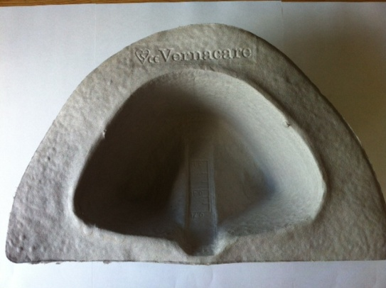
- Place the clean collection container under your toilet seat; towards the back of the toilet to collect stool. For infants/toddlers, stool can be collected directly from a soiled diaper or “potty”.
Note: feces specimens that have been in contact with water in the toilet are unacceptable.
- Urinate prior to collecting a stool specimen so that urine does not contaminate the stool sample.
- Pass stool into the collection container.
- Transfer the stool into the specimen containers by following the instructions below:
  - Green-capped container: Remove the lid of the container. Use the spoon attached to the lid to transfer stool (including any blood or mucous) into the container up to the fill line (do not overfill). Mix the stool into the red jelly-like substance already in the container using the spoon. Recap the container and tighten the lid.
  - White-capped container: Remove the lid of the container. Use the spoon attached to the lid to transfer stool (including any blood or mucous) into the container up to the red line. DO NOT OVERFILL. Recap the container and tighten the lid.
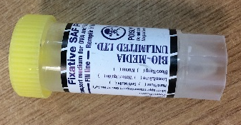
  - Yellow-capped container (if provided): Remove the lid of the container. Use the spoon attached to the lid to transfer stool (including any blood or mucous) into the container up to the fill line (do not overfill). Mix the stool into the clear liquid already in the container using the spoon. Recap the container and tighten the lid.
- Wash hands thoroughly with soap and warm water for at least 15 seconds or use hand sanitizer.
- Complete the label on each specimen container with a black or blue pen, including:
  - Patient’s name and one other unique identifier (date of birth or health insurance number [must match information on the General Test Requisition]. Failure to provide this information may result in specimen rejection or delay).
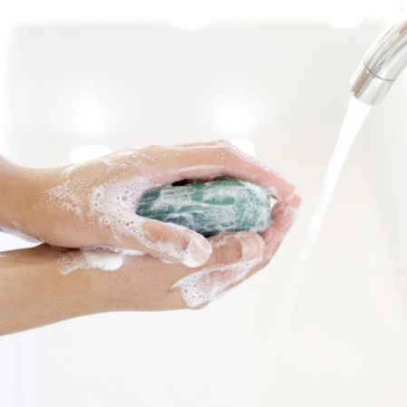
  - Date sample was collected.
- Place all specimen containers provided in the plastic bag and seal the bag.
- Complete all fields of the requisition and place it in the pocket on the outside of the sealed biohazard bag.
- Carefully remove the collection container from the toilet and dispose of remaining stool in the toilet. If you have used a reusable container such as a potty, clean with your usual toilet cleaner. If you have used a disposable container, place in a disposable bag and in your garbage bin.
- Wash hands thoroughly with soap and warm water for at least 15 seconds or use hand sanitizer.
- Refrigerate samples immediately, do not freeze.
- Contact the Health Unit for questions or concerns at 705-474-1400 or toll-free at 1-800-563-2808, ext. 5229.

