Light Up
ROAD CLOSURE NOTICE
Oct 02, 2025
This notice is to inform you of road closures impacting Downtown Stony Plain on Nov 30th.
The Town of Stony Plain is hosting it’s annual Christmas Tree Light Up. This event, in Downtown Stony Plain, intends to:
- Gather our community into Downtown Stony Plain and interact with its businesses
- Increase visibility and positive public relations with local businesses
- Increase familiarity with Downtown Stony Plain as a destination and focal point of our community
The road closure will encompass 50 Street from 50 Avenue to 52 Avenue and 51 Avenue from the Traffic Circle up to the east and west alleyways. The closure will occur from 3 PM to 8:30 PM on November 30th. A map outlining the closure is attached to this notice.
Businesses within the event area should prepare customers for the closure and advise that vehicles must be removed by 3 PM at the latest or risk being towed.
Downtown businesses outside the event area will be impacted by increased vehicle traffic and people parking in public parking spaces to attend the event. The road closure and public parking will be communicated in conjunction with the event. Downtown businesses are kindly asked to help mitigate impacts by informing customers before the event and preparing them to utilize alternative parking. To assist you in this, a parking map is attached to this notice and is available at the link below. All Downtown Stony Plain businesses are invited to participate in and add to the value of the event. To learn more about the event and how to participate, www.StonyPlain.com/WinterFest
Lori Van Dommelen
Event Coordinator, Town of Stony Plain
events@stonyplain.com

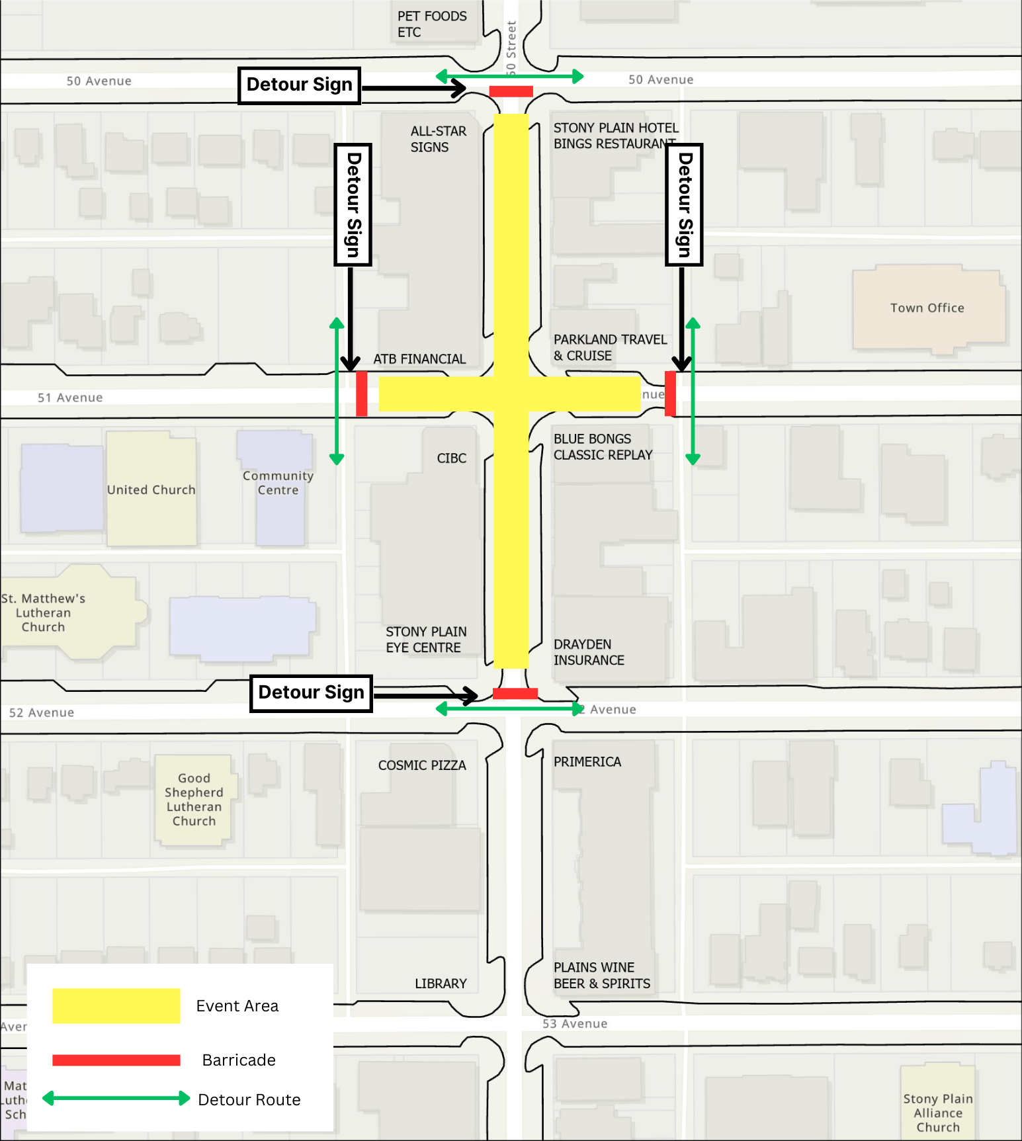
Road Closure Map
Downtown Stony Plain Parking Map
